|  |
| --- |
| Fire and Explosion Risk Analysis  H.2495/2502/03/04/06 174k LNGC (X-DF) |
| Report for:  Daewoo Shipbuilding and Marine Engineering Co., Ltd. |



Summary

|  |  |  |  |
| --- | --- | --- | --- |
| Fire and Explosion Risk Analysis | | | |
| **H.2495/2502/03/04/06 174k LNGC (X-DF)** | | | |
| **Security classification of this report:** Distribute only after client's acceptance | | | |
| **Report no:**  PRJ1110020880-04 | **Revision:**  A | | **Report date:**  8 May 2020 |
| **Prepared by:**  Sam-Heon Jeong  Principal Consultant  __________________________ | **Reviewed by:**  Sung-Hoon Kim  Principal Consultant  __________________________ | | **Approved by:**  Dong-Hoon Han  Risk Service Manager Korea  __________________________ |
| **Entity name and address:**  Lloyd's Register Asia  11th Floor CJ Korea Express Bldg.  119 Daegyo-ro, Jung-gu  48943 Busan  Republic of Korea | | **Client name and address:**  Daewoo Shipbuilding and Marine Engineering Co., Ltd.  3370, Geoje-daero, Geoje-si, Gyeongsangnam-do, 53302  Republic of Korea | |
| **Our contact:**  Kyung-Tae Moon  T: +82 (0)51 640 5069  E: kyung-tae.moon@lr.org | | **Client contact:**  Jae-Cheon Cho  T: +82 (0)55 735 5010  E: jccho@dsme.co.kr | |
| Lloyd’s Register Group Limited, its subsidiaries and affiliates and their respective officers, employees or agents are, individually and collectively, referred to in this clause as ‘Lloyd’s Register’. Lloyd’s Register assumes no responsibility and shall not be liable to any person for any loss, damage or expense caused by reliance on the information or advice in this document or howsoever provided, unless that person has signed a contract with the relevant Lloyd’s Register entity for the provision of this information or advice and in that case any responsibility or liability is exclusively on the terms and conditions set out in that contract.  Except as permitted under current legislation no part of this work may be photocopied, stored in a retrieval system, published, performed in public, adapted, broadcast, transmitted, recorded or reproduced in any form or by any means, without the prior permission of the copyright owner. Enquiries should be addressed to Lloyd’s Register, 71 Fenchurch Street, London, EC3M 4BS.  ©Lloyd’s Register 2020. | | | |

Document history

| Revision | Date | Description/changes | Changes made by |
| --- | --- | --- | --- |
| A | 8 May 2020 | First Issue | Samheon Jeong |

Executive summary

The fire and explosion risk in the CCR and ER of H2496s LNG carrier has been addressed in this study.

The LNG process is analysed for isolatable segments and leak frequencies from each segment are evaluated using LR RMC’s tool ULF.

Explosion risk analysis

The explosion risk in the CCR and ER of H2496s LNG carrier has been addressed in this study. Generally, the explosion risk on H2496 is modest and well within the risk acceptance criteria. Below is a summary of the main findings:

* Maximum accidental design load observed in the CCR over 1E-4 per year is 2.24 barg that CCR ceiling experiences. It should be noted that the study applied the 1E-4 per year of impairment frequency for offshore oil & gas project thus judgement on derived loads should be made considering operation life of H2495s.
* No meaningful accidental design loads observed in the ER over 1E-4 per year are observed due to limited accommodation of fuel gas process within ER that leads to very low leak frequency. It can be concluded that the dimensioning accidental loads on the ER of 2495s are acceptable.

Overall, the present study demonstrates that the design of H2495s CCR and ER are vulnerable to explosion have a sufficient robustness, and all of the acceptance criteria related to explosion loads are met.

Fire risk analysis

Fire risk analysis is performed using PHAST to evaluate consequences for flammable gas dispersion, flash fire, and jet fire. Combining the frequency and the jet fire length expected from each leak events, dimensioning fire scenario is derived. At the instant of release, the dimensioning jet fire in CCR will be 5.5 meter long. The jet fire, however, will shrink quickly as the release rate decreases in time. In five minutes the cumulative frequency of having a jet fire will be less than dimensioning.

Abbreviations

|  |  |
| --- | --- |
| BOG | Boil-Off Gas |
| CAD | Computer Aided Design |
| CCR | Cargo Compressor Room |
| CFD | Computational Fluid Dynamics |
| DAL | Dimensioning Accidental Load |
| ER | Engine Room |
| ESDV | Emergency ShutDown Valve |
| ERA | Explosion Risk Analysis |
| FERA | Fire and Explosion Risk Analysis |
| FLACS | Flame Acceleration Simulator |
| GE | Generator Engine |
| GVU | Gas Valve Unit |
| K.O. drum | Knock Out drum |
| ME | Main Engine |
| PRS | Pressure Regulation System |
| PP | Panel Pressure |
| STBD | Starboard |
|  |  |

Table of contents Page

1 Introduction 1

1.1 Background 1

1.2 Objective 1

1.3 Scope of works 1

1.4 Base documentation 1

2 System description 2

2.1 General 2

2.2 Operation mode 3

2.3 Cargo compressor room 3

2.4 Engine room 4

2.5 LNG and BOG properties 4

3 Methodology 4

4 Leak frequency estimation 5

4.1 Area segmentation 5

4.2 Segment classification 5

4.3 Part count 6

4.4 Leak category 7

4.5 Leak frequency as per leak rate 7

4.6 Total leak frequency 8

4.7 Leak duration 9

5 Consequence analysis for Explosion Risk Analysis 10

5.1 Geometry modelling 10

5.2 Ventilation simulations 11

5.3 Gas dispersion 11

6 Ignition modelling 17

6.1 General 17

6.2 Ignition probabilities 18

6.3 Ignited cloud volumes 19

7 Explosion simulations 20

7.1 Explosion load targets 20

7.2 Simulated scenarios 22

7.3 Numerical aspects 23

7.4 Overpressure vs ignited cloud size 25

7.5 Explosion load durations 28

8 Probabilistic explosion loads 31

8.1 Pressure-frequency curves for CCR 31

8.2 Pressure-frequency curves for ER 33

9 Fire Risk Analysis using PHAST in CCR 36

9.1 Discharge Calculation 36

9.2 Consequence Calculation 38

9.3 Dimensioning Load Evaluation 39

10 Conclusion 41

11 References 41

**Appendix A Time-Varying Discharge Profiles for FRA**

**Appendix B Consequence Analyses for FRA**

# Introduction

## Background

Lloyd's Register Risk Management Consulting (LR RMC) has been engaged by Daewoo Shipbuilding and Marine Engineering Co., Ltd. (DSME) to perform a fire and explosion risk analysis (FERA) on the cargo compressor room and the engine room of H.2495/2502/03/04/07 LNG carriers, hereafter called the vessel. The vessel is being built in DSME.

## Objective

The objective is of the FERA is to assess the risk by assessing consequence of fire resulting from ignition of released flammable gas and consequence of explosions from accumulation and subsequent ignition of flammable gas in the cargo compressor room (CCR) and the engine room (ER) of H2495s 174k LNG carriers.

## Scope of works

Fire and explosion risk with the possibility of flammable gas leakage in the CCR and the ER will be assessed.

## Base documentation

The documents listed in Table 1.1 constitute the basis of this FERA.

Table . Base documentation

| Doc./Dwg. No. | Rev. | Title |
| --- | --- | --- |
|  |  | Frequency Estimation |
| DA800D131 | 0 | Cargo piping diagram |
| DA800D139 | A | Cargo functional diagram |
| H2495-FS-R1 | - | Specification cargo equipment |
| DV363D029 | A | Vendor drawing of advanced partial reliquefaction system |
| B463043 | R0 | Vendor drawing of BOG boosting compressor |
| 0032334 | R2 | Vendor drawing of FG compressor |
|  | 0 | Fire and explosion risk analysis for engine room and cargo compressor room in H2495 |

# System description

## General

Main particulars of the vessel are listed as follows:

|  |  |
| --- | --- |
| Dimensions |  |
| Length, overall | abt. 294.9 m |
| Length between perpendiculars | 288.5 m |
| Breadth, moulded | 46.4 m |
| Depth, moulded | 26.5 m |
| Design draught, moulded | 11.5 m |
| Cargo tanks | 4 x GTT membrane type GTT NO 96-GW, BOR: 0.104% (3,850kg/h) |
| BOG handling equipment |  |
| FG compressor | 2 x Kobelco, Oil-injected screw type, 2-stage, 6,600 m3/h |
| BOG boosting compressor | 2 x Kobelco, KR50V-2, 4,800 kg/h |
| Reliquefication unit | 1 x Sunbo, A-PRS, 2,800 kg/h (at laden voyage) |
| Propulsion and power generation systems |  |
| Propulsion system |  |
| Generator engines (No.1 and 4) | 2 x Wartsila 6L34DF, 2,880 kW, 720 rpm |
| Generator engines (No.2 and 3) | 2 x Wartsila 8L34DF, 3,840 kW, 720 rpm |

Figure 2.1 shows the general arrangement of the vessel.

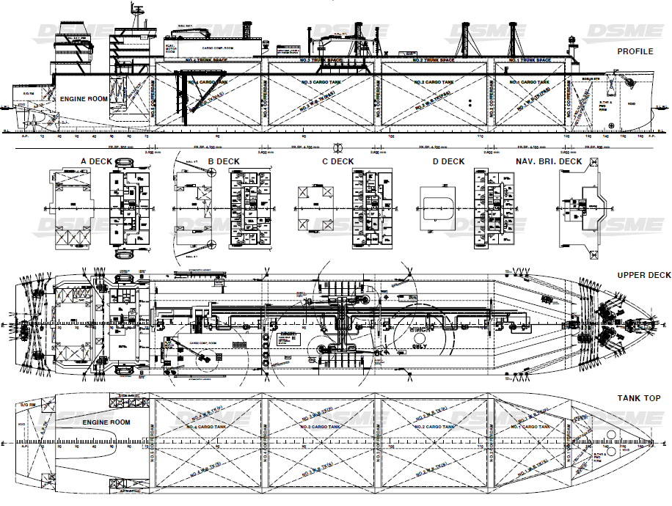

Figure . Maran Gas H.2495s 174k LNG Carriers

## Operation mode

The fuel gas supply system takes BOG from the cargo tanks via vapour main, pressurised it, and supplies fuel gas to the X-DF type main engines (MEs) and DF type generator engines (GEs).

In the FERA, the normal operation mode is mainly considered to estimate the risk of fire and explosion. The schematic diagram of fuel gas supply to the engines during normal operation is shown in Figure 2.2.

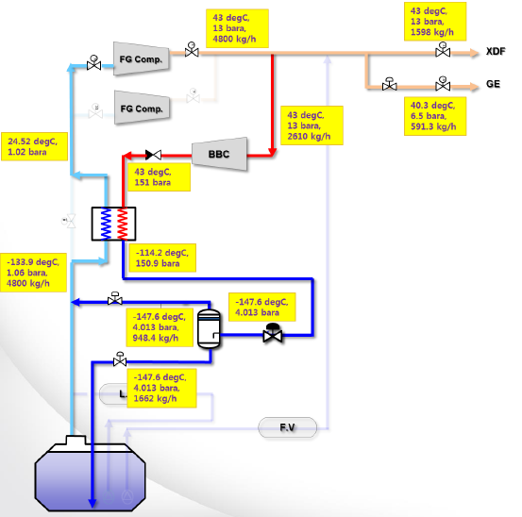

Figure . Fuel gas supply to the engines during normal operation

The following equipment is necessary for fuel gas supply to propulsion and generator engines:

* Cargo tank and manifold
* A-PRS
* Fuel gas compressor (FG Compressor)
* BOG boosting compressor (BBC)
* GVU for propulsion engine
* GVU for generator engine

## Cargo compressor room

The cargo compressor room is located at STBD side on ‘upper’ deck, Figure 2.3 shows the location of the cargo compressor room.



Figure . Location of the cargo compressor room

The necessary equipment for the normal operation is installed in the cargo compressor room.

The cargo compressor room is ventilated with three natural ventilators and four mechanical exhaust fans to provide sufficient air changes in the room.

## Engine room

Pressurized natural gas from the FG compressor is supplied to the propulsion and the generator engines via gas valve unit (GVU). The ME GVUs are mounted on each propulsion engine side, while the GE GVUs are installed in the GE GVU room. The GVU room is located on 2nd deck of the engine room.

The ventilation system is provided to supply fresh air into the engine room that can be used as combustion air for propulsion and generator engines. It consists of ducts routed to several areas in the engine room, four ventilation fans, dampers and their control system.

## LNG and BOG properties

The specific properties of LNG and BOG are determined by considering LNG and BOG compositions listed in Table 2.1. The compositions refer to the design basis document.

Table 2.1 LNG and BOG compositions

| Compositions | LNG (mol %) | BOG (mol %) |
| --- | --- | --- |
| Nitrogen (N2) | 0.35 | 7.75 |
| Methane (CH4) | 95.74 | 92.23 |
| Ethane (C2H6) | 3.20 | 0.02 |
| Propane (C3H8) | 0.60 | - |
| Butane (C4H10) | 0.10 | - |
| Hydrocarbons C4+) | 0.01 | - |

# Methodology

FERA follows a stepped approach to evaluate risk of fire and explosion.

The process is analysed for isolatable sections and their process condition with availability of safety systems. Characteristics of leakage is evaluated that will be inputs for consequence analysis of fire and explosion.

Frequency of hydrocarbon accident will be related to degree of consequences to evaluate dimensioning scenarios.

In this study, the leak frequency is performed in Section 4 using LR RMC’s tool ULF.

Section 5, 6, 7, and 8 are for probabilistic explosion risk analysis using LR RMC’s methodology using ExploRAM to derive the dimensioning explosion load in CCR and ER.

Section 9 is for fire risk analysis in CCR using PHAST as an efficient consequence analysis tool. Dimensioning jet fire scenarios are derived using exceedance curves in CCR. PHAST analysis uses leak frequencies for hole sizes that is also calculated by ULF.

# Leak frequency estimation

## Area segmentation

For the frequency estimation of probable leakage, three (3) areas are defined to include equipment for fuel gas propulsion and power generation systems. The following three areas are considered to estimate the leak frequency:

* A01: Cargo compressor room
* A02: Manifold at outside CCR & ER
* A03: Engine room

## Segment classification

The fuel gas supply systems for propulsion and generator engines are segregated into nine (9) segments as enlisted in Table 4.1. The segments are limited by the emergency shutdown valves (ESDVs).

Table . Description of segment and area

| Segment No. | Description | Area |
| --- | --- | --- |
| Segment 1 | A-PRS | A01 |
| Segment 2 | A-PRS to FG compressor | A01 |
| Segment 3 | FG compressor | A01 |
| Segment 4 | FG compressor to MEs & DFGEs | A02 |
| Segment 5 | Master gas valve (CG405) to ME (S) | A03 |
| Segment 6 | Master gas valve (CG415) to ME (P) | A03 |
| Segment 7 | Master gas valve (CG416) to DFGE | A03 |
| Segment 8 | BOG boosting compressor to A-PRS | A01 |
| Segment 9 | BOG return from A-PRS | A01 |

Figure 4.1 and Figure 4.2 show the segments arranged in CCR and ER respectively.



Figure . Segments related to the cargo compressor room (A01)



Figure . Segments related to outside the CCR (A02) and ER (A03)

## Part count

FERA uses LR’s in-house software ULF for leak frequency estimation, which is based on A DNV report (Ref. [[1]]). In the report, In the report, equipment is categorized as shown in Table 4.2. All types of manual valves (bleed, block, check and choke) are included in ‘Valve, manual.’ All other types of non-pipeline actuated valves (block, blowdown, choke, control, ESDV and relief, but not pipeline ESDV and SSIV) are in ‘Valve, actuated.’ All types of pressure vessel (horizontal/vertical absorber, KO drum, other, reboiler, scrubber, stabiliser, separator and stabiliser) are included in the category of ‘Pressure vessels.’

Using this base data set developed, the release frequency is calculated by combining the frequency data set and the "parts count" results. The parts count of each identified isolatable section is undertaken from the P&IDs to estimate the number of potential leak sources.

Table . Equipment category used in DNV report

| DNV equipment type | HCRD equipment types |
| --- | --- |
| Steel pipes  Flanged joints  Manual valves  Actuated valves  Valves  Instruments  Process vessels  Atmospheric vessels  Centrifugal pumps  Reciprocating pumps  Centrifugal compressors  Reciprocating compressors  Shell side heat exchangers  Tube side heat exchangers  Plate heat exchangers  Air cooled heat exchangers  Filters  Pig traps | Piping, Steel (3 sizes)  Flanges (3 sizes)  Valve, manual (10 types & sizes)  Valve, actuated, non-P/L (18 types & sizes)  The sum of manual and actuated valves  Instruments  Pressure vessel (14 types)  Vessels at atmospheric pressure  Pumps, centrifugal (2 seal types)  Pumps, reciprocating 2 seal types)  Compressors, centrifugal  Compressors, reciprocating  Heat exchanger, HC in shell  Heat exchangers, HC in tube  Heat exchangers, plate  Fin fan coolers  Filters  Pig launchers & pig receivers (4 sizes) |

## Leak category

Refer to Table 4.3. The leak rates and frequencies are distributed by four (4) leak categories. Leaks smaller than 0.1 kg/s are neglected due to negligible consequences.

Table 4.3 Leak categories by leak rates

| Leak category | | Leak rate range (kg/s) |
| --- | --- | --- |
| Small | SM | 0.1~1 |
| Medium | ME | 1 ~10 |
| Major | MA | 10 ~60 |
| Large | LA | > 60 |

## Leak frequency as per leak rate

LR RMC reviewed the latest P&IDs for part-counting and used its tool ULF to assess the release frequencies. The typical leak rates have been calculated on the basis of output from ULF, and the leak frequency as per leak rate for each segment are tabulated in Table 4.4.

Table . Leak frequency as per leak rate for each segment

| Seg. No. | Small | Medium | Major | Large |
| --- | --- | --- | --- | --- |
| Segment 1 | 1.17E-03 | 5.71E-04 | 5.37E-04 | 0.00E-00 |
| Segment 2 | 9.39E-05 | 9.82E-05 | 4.39E-05 | 0.00E-00 |
| Segment 3 | 1.37E-02 | 4.75E-03 | 2.00E-03 | 5.02E-04 |
| Segment 4 | 1.11E-03 | 3.47E-04 | 2.96E-04 | 6.90E-05 |
| Segment 5 | 1.86E-03 | 7.80E-04 | 5.20E-04 | 0.00E-00 |
| Segment 6 | 1.46E-03 | 6.18E-04 | 3.42E-04 | 0.00E-00 |
| Segment 7 | 1.01E-02 | 7.30E-03 | 3.74E-05 | 0.00E-00 |
| Segment 8 | 9.65E-02 | 3.78E-02 | 1.25E-02 | 4.37E-03 |
| Segment 9 | 3.98E-03 | 1.85E-03 | 9.90E-04 | 6.16E-05 |

## Total leak frequency

The total leak frequency due to process accidents on H2495s LNG Carrier during normal operation is calculated to be 2.46E+00 per year, as shown in Table 4.5.

Table . Total leak frequency

|  | | Leak Frequency (per year) | | | | |
| --- | --- | --- | --- | --- | --- | --- |
| SM  [0.1<-≤1] | ME  [1<-≤10] | MA  [10<-≤60] | LA  [60< ] | TOTAL |
| NG | Gas leak frequency | 1.26E-01 | 5.22E-02 | 1.63E-02 | 4.94E-03 | 1.99E-01 |
| LNG | Liquid leak frequency | 3.98E-03 | 1.85E-03 | 9.90E-04 | 6.16E-05 | 6.88E-03 |
| Total | Total leak frequency | 1.30E-01 | 5.41E-02 | 1.73E-02 | 5.00E-03 | 2.06E-01 |
|  | % contribution | 63 | 26 | 8 | 2 | 100 |

Leak frequency per leak category for normal operation is shown Figure 4.3.

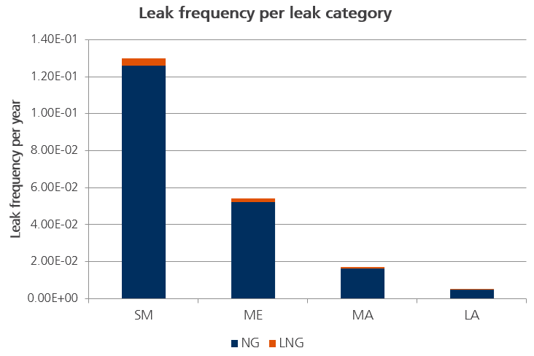

Figure . Leak frequency per leak category

## Leak duration

Each segment has different operating conditions and properties. The detailed operating conditions for each segment are listed in Table 4.6.

Table . Operating conditions, volume, and total mass of the segment

| Seg No. | Phase | Temp. (°C) | Pressure (bara) | Mass flowrate (kg/s) | Density (kg/m3) | Volume (m3) | Total mass (kg) |
| --- | --- | --- | --- | --- | --- | --- | --- |
| 1 | Gas | -133.9 | 1.05 | 1.33 | 1.65 | 6.00 | 9.9 |
| 2 | Gas | 24.5 | 1.02 | 1.33 | 1.65 | 6.00 | 9.9 |
| 3 | Gas | 43.0 | Outlet:13 | 1.33 | 5.55 | 6.36 | 35.3 |
| 4 | Gas | 43.0 | 13.00 | 1.33 | 8.53 | 3.34 | 28.5 |
| 5 | Gas | 43.0 | 13.00 | 0.22 | 8.53 | 0.46 | 3.9 |
| 6 | Gas | 43.0 | 13.00 | 0.22 | 8.53 | 0.46 | 3.9 |
| 7 | Gas | 43.0 | 6.50 | 0.16 | 4.27 | 7.20 | 30.7 |
| 8 | Gas | 43.0 | Outlet:151 | 0.73 | 110.78 | 6.05 | 362.1 |
| 9 | Liquid + Gas | -147.6 | 4.01 | 0.46 | Liq.:394.40Gas: 7.98 | Liq.: 0.37 Gas: 1.90 | 161.1 |

The duration of leakages is estimated by using an in-house tool ‘transient leak tool (TLT)’. TLT accounts for the transient nature of such leakages by considering the provision of safety systems, such as gas detection, emergency shutdown, blowdown, etc.

The operating conditions listed in Table 4.6. are used for the input data of TLT, and the output (a text file) from TLT is used as input to ExploRAM calculations.

# Consequence analysis for Explosion Risk Analysis

## Geometry modelling

This chapter describes the CFD geometry model of the H2495s cargo compressor room (CCR) and the engine room (ER) to be applied in the study. LR received a 3D geometry model from DSME in the format of Microstation DGN v7 and has converted and adapted it into a format applicable to be used in CFD explosion studies. An overview of the developed model can be seen in Figure 5.1 and Figure 5.2.

Note that in the process of establishing a CFD model to be used in dispersion, explosion simulations, focus is on obtaining a realistic representation of the process area where there is a potential for a major accident. Due to the complexity of the engine room geometry the configuration of the room was simplied for CFD modelling.

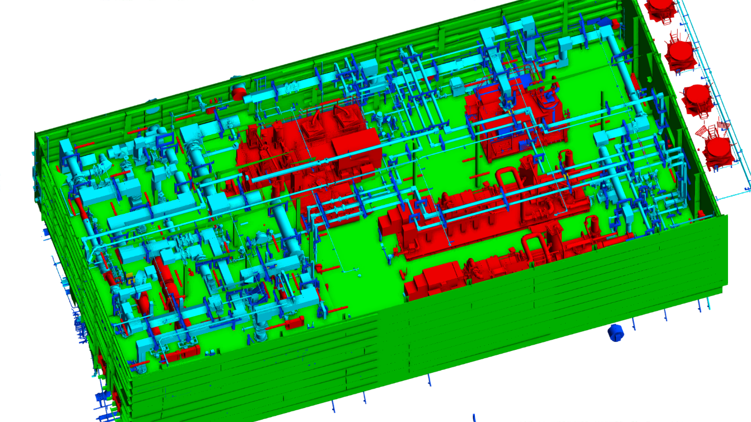

Figure . FLACS 3D model of Compressor room

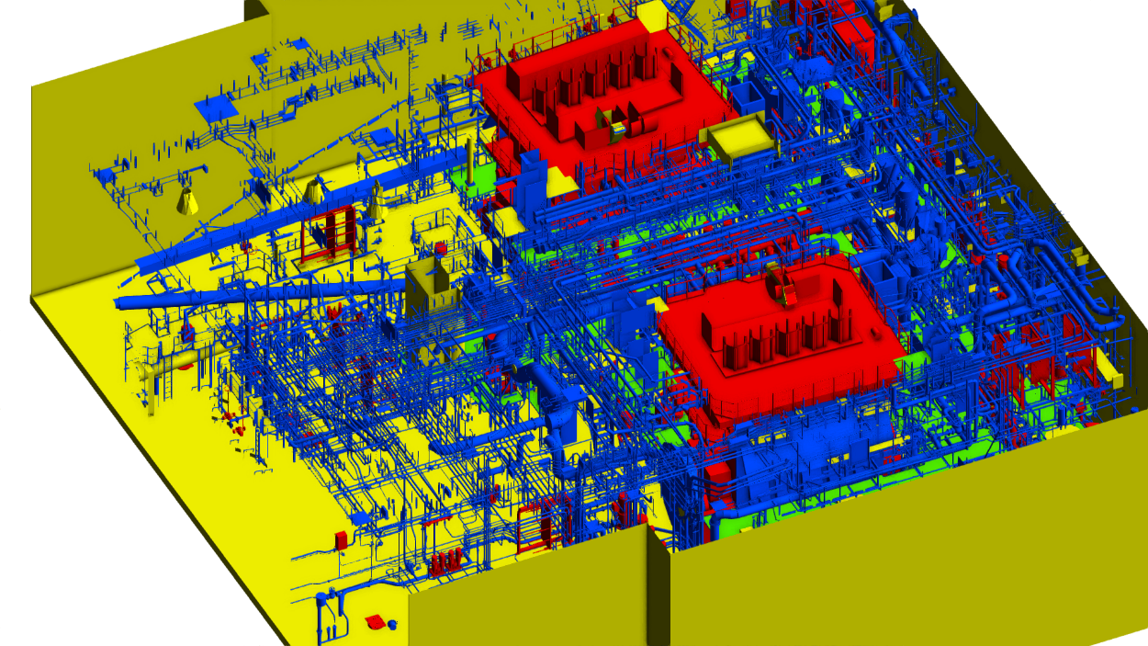

Figure . FLACS 3D model of Engine room

### Model cleaning and platform grating

Dummy objects may appear in the conversion from the DGN to the FLACS format. These dummies are non-physical and can be due to blocked out area for maintenance, objects visualising crane operating radius or simply erroneous conversion of objects. These dummies have been removed by LR. Dummy volumes for door opening and operators were also removed and these would only increase the congestion to unrealistic levels.

All platforms and walls have been removed after the import and rebuilt in FLACS. This is to ensure that they will be completely impermeable and placed at the intended location and that monitor panels will in fact measure the load on the surface of the wall/platforms.

Small hoods, cabinets and electrical boxes are typically converted to solid boxes, in order not to confuse the sub-grid turbulence model in FLACS. These objects might contain even smaller parts internally.

There are several small platforms around the engines. These platforms are grated and are given a porosity of 0.5 in FLACS.

## Ventilation simulations

Ventilation simulations shows the flow pattern and air change rate inside the rooms, both of which are affected by the mechanical air supply/ extraction. The mechanical ventilation rate primarily determines the size and shape of the gas clouds. Mechanical ventilations provided at each of Compressor room and Engine room are presented in Table 5.1. Based on rough estimation of room volumes, Air Change per Hour at Compressor room (6,122m3) is estimated with 32 while Engine room is assumed to be provided with more than 20 ACH based on the current ventilation system.

Table . Mechanical ventilation for Compressor room and Engine room

| Area | Mechanical air supply | Air flow, m3/h | Remark |
| --- | --- | --- | --- |
| Compressor room | Cargo compressor room natural supply (3 sets) | 189,900 | Natural air supply 63300 m3/h (each) |
| Cargo compressor room exhaust fan (2 sets working, 2sets stand-by) | 190,000 | Exhaust fan capacity 95000 m3/h (each) |
| Engine room | No.1 Engine room supply fan | 120,000 | 1st, 2nd, partial deck, floor |
| No.2 Engine room supply fan | 120,000 |
| No.3 Engine room supply fan | 120,000 | B deck, upper deck, 1st deck, 2nd deck. |
| No.4 Engine room supply fan | 120,000 |

## Gas dispersion

This chapter gives an overview of the analysis of gas dispersion from hydrocarbon process leaks on Compressor room and Engine room.

### Simulated scenarios

The number of possible leak scenarios, i.e. the combination of leak hole dimensions, leak positions, leak directions and ventilation conditions (as determined by mechanical ventilation) is very large compared to the number of simulations feasible to perform. Hence, simulations are performed for a selected set of scenarios, while the majority of scenarios are approximated based on the simulation results. The number of CFD-simulated scenarios $N$ in a module is given by

$N=N_{a}N_{ld}N_{w}N_{lr}$

Here, $N_{a}$ is the number of simulated leak locations, $N_{ld}$ the number of simulated leak directions, $N_{w}$ the number of simulated air flow rate and $N_{lr}$ the number of simulated leak rates. The CFD-simulated scenarios and the scenarios approximated based on the simulated ones are used in the probabilistic analysis.

Total 72 dispersion simulations (54 for leaks in Compressor room, 18 for Engine room release scenarios) were executed for the compressor room and engine room. This includes 4 leak locations (3 at Compressor room and one at Engine room), 3 leak rates, one ventilation condition and 6 leak directions.

A summary of the simulated dispersion scenarios can be found in and the position of the leak points are shown in Table 5.2, Figure 5.3 and Figure 5.4.

Table . Overview of gas dispersion simulations for H2495s CCR and ER

| Leak no. | Leak location | Leak rates [kg/s] | Leak directions | Air flow, m/s | Total number |
| --- | --- | --- | --- | --- | --- |
| 1 | Fuel gas inlet line, CCR | 1.5, 6, 24 | E, W, N, S, D, U | 3.7 | 54 |
| 2 | Discharge of Booster compressor, CCR | 1.5, 6, 24 | E, W, N, S, D, U | 3.7 |
| 3 | Discharge of FG compressor, CCR | 1.5, 6, 24 | E, W, N, S, D, U | 3.7 |
| 4 | Fuel gas line connection to ME, ER | 1.5, 6, 24 | E, W, N, S, D, U | 3.7 | 18 |

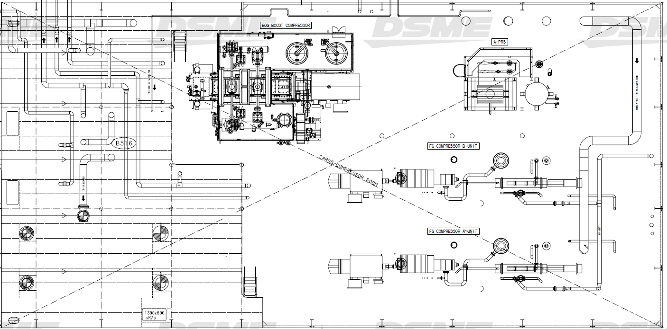

**Leak 3**

**Leak 2**

**Leak 1**

Figure . Simulated leak locations in CCR

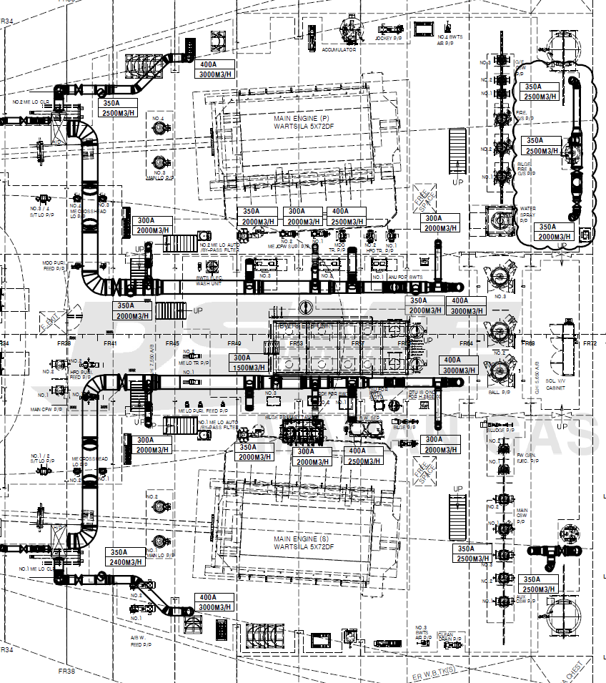

**Leak 4**

Figure . Simulated leak locations in ER

### Simulation set-up

#### Numerical aspects

For the dispersion simulations, the incompressible solver in FLACS is applied with a fixed time step of 0.075 s. For the first 60 s of a simulation, only the ventilation flow vector field is solved. Then, at 300 s the leak is switched on. In that manner a stable wind field is established prior to the onset of the leak. The simulations are run until they reach steady state with a fixed release rate.

The computational domain extents half of the room dimension length from the edge of each CCR and ER in all four directions. As the rooms are fully enclosed the simulations are not sensitive to the length of extended dimension. Within each room, a grid resolution of 0.5 m is applied at the walls of the rooms and the grid is stretched further towards the end of the computational domain. The grid is refined in the region perpendicular to the leak to make sure that the jet is not too strongly diluted initially. The total number of computational cells lies in about 166,000 for CCR and 580,000 for ER, for all simulations.

#### Gas composition

Very small amount of heavy hydrocarbon components (>C3) were merged in C2 and nitrogen contents was assumed to be negligible to simplify the simulation calculation. In the simulations, 96% of CH4 and 4% of C2H6 were used.

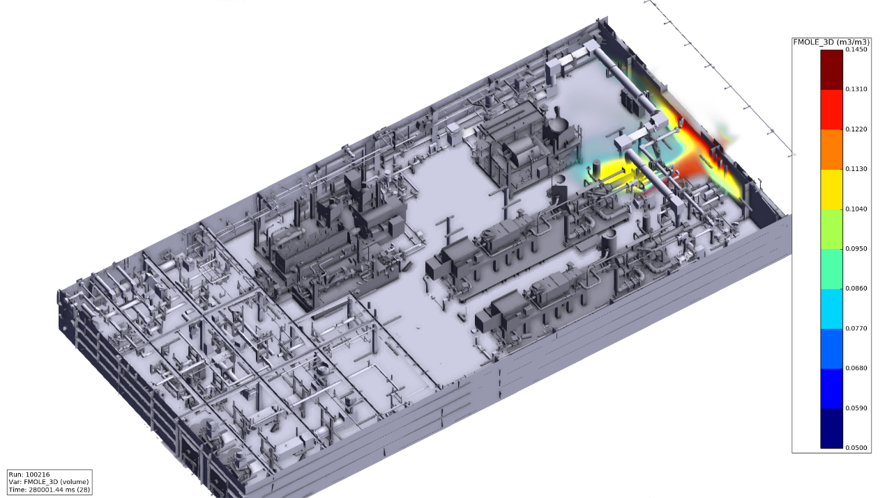

Figure . Sample simulation result: flammable gas cloud in LFL-UFL from 1.5 kg/s leak in CCR

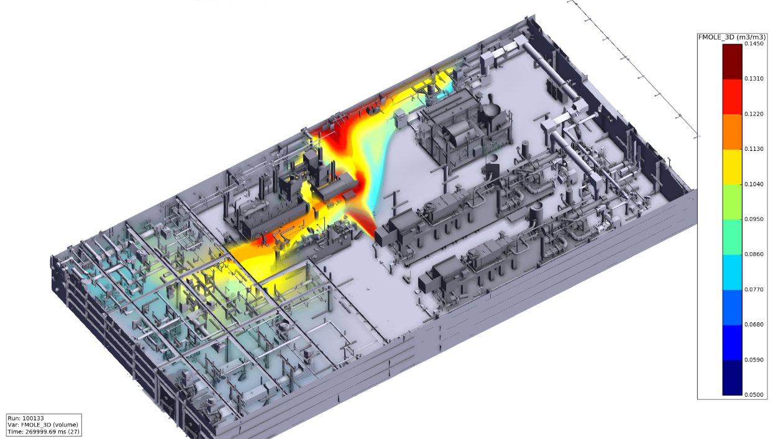

Figure . Sample simulation result: flammable gas cloud in LFL-UFL from 6 kg/s leak in CCR

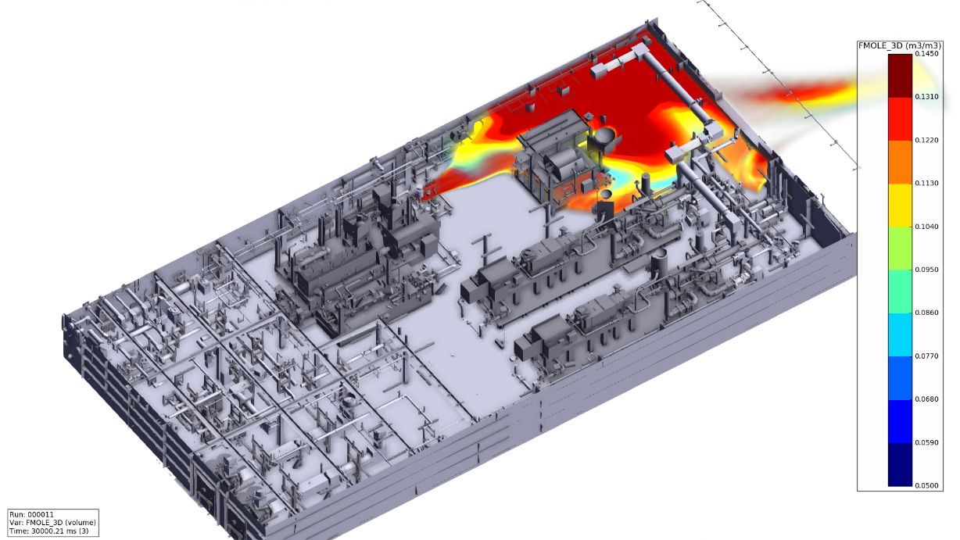

Figure . Sample simulation result: flammable gas cloud in LFL-UFL from 24 kg/s leak in CCR

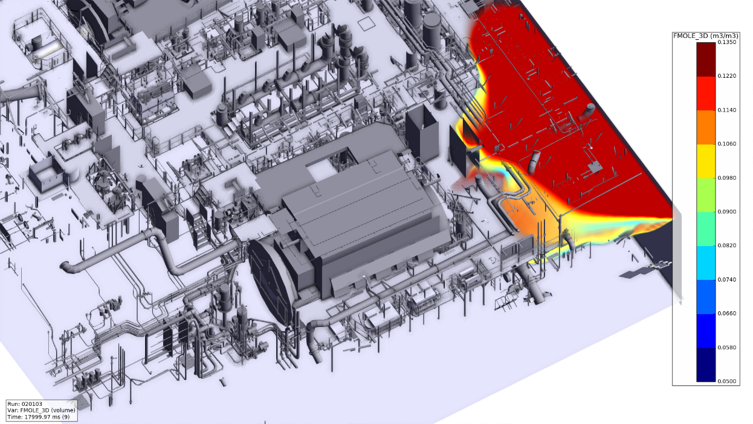

Figure . Sample simulation result: flammable gas cloud in LFL-UFL from 1.5 kg/s leak in ER

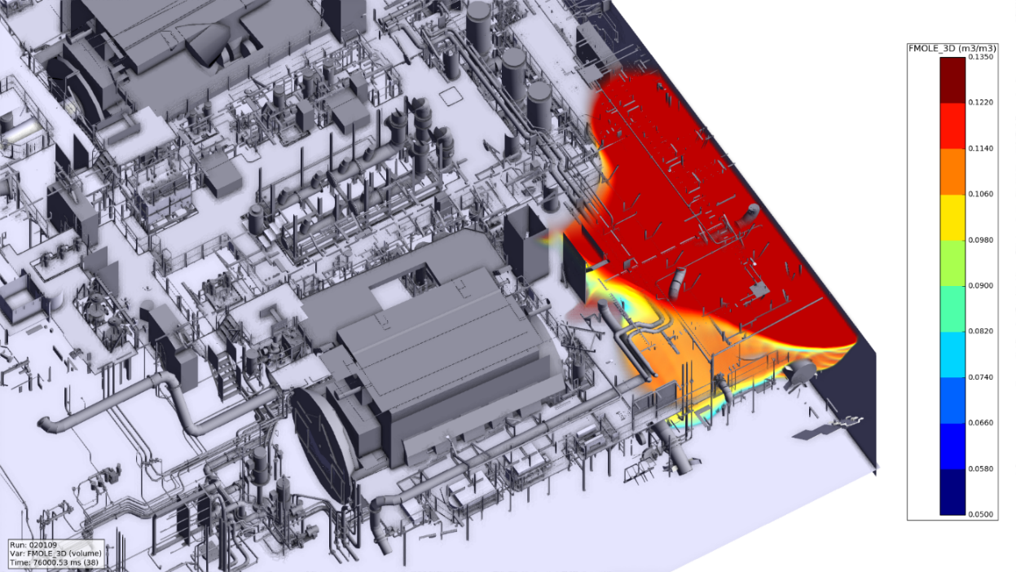

Figure . Simple simulation result: flammable gas cloud in LFL-UFL from 6 kg/s leak in ER

### Frequency weighted clouds

This section displays frequency weighted steady-state gas clouds for the probabilistic ERA of H2495s. These plots are based on the simulated gas dispersion scenarios and the interpolation/ extrapolation routines in the applied probabilistic tool. They can be understood as providing the most probable gas cloud for a given leak rate.

Figure 5.10 and Figure 5.11 show the frequency weighted cloud sizes for fuel gas leaks in the CCR and ER, H2495s. The figures display both the volume of gas which has a concentration above LFL (blue line) and the flammable volume (red line). The difference between the curves is the volume above UFL. The gas clouds start to become rich at a release rate of approximately 6 kg/s for CCR and appx. 2.5 kg/s for ER.

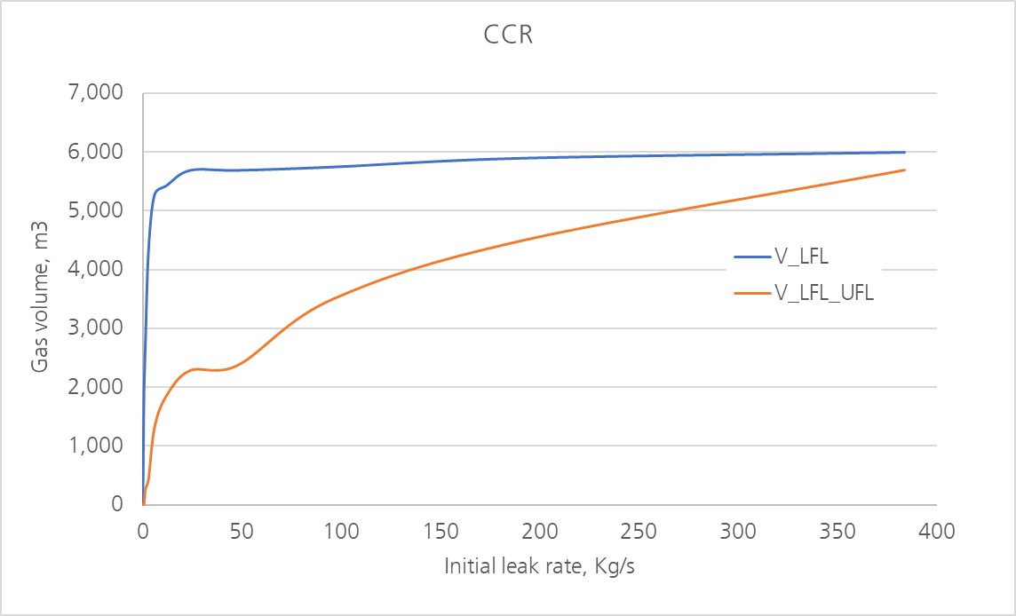

Figure . Frequency weighted steady state cloud volumes as a function of initial leak rate for H2495s CCR

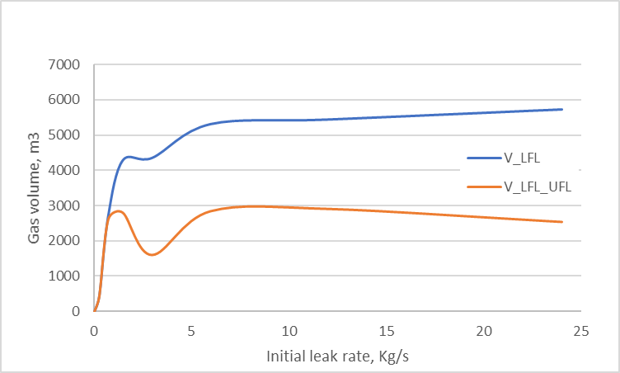

Figure . Frequency weighted steady state cloud volumes as a function of initial leak rate for H2495s ER

# Ignition modelling

## General

In case of a hydrocarbon release there is a probability for the release to ignite causing an explo­sion and/or a fire event. The ignition probability is time dependent and is, in addition to the type and density of ignition sources in the area, determined by the size of flammable cloud as a func­tion of time.

Ignition sources are in the following divided into 4 different categories:

* Event ignition is the ignition probability caused by the leak itself (or the same initiating event is causing both the leak and the ignition) and is assumed to occur instantly and before any significant cloud has developed. It will thus not contribute to the explosion frequency but constitutes a significant part of the fire frequency
* Continuous ignition sources. An ignition source is continuous by having constant or decreasing strength. If ignition occurs, this is assumed to happen at first exposure of the ignition source. Hence, the ignition probability in a time step is proportional to the volume exposed to flammable gas for the first time in the actual time step. Longer exposure time for the same cloud will in the model not lead to a larger ignition probability, since the ignition model assumes immediate ignition.
* Discrete ignition sources. Discrete ignition sources are ignition sources that exert sparks at intermittent points in time. Probability of ignition from discrete ignition sources in a time step is thus assumed proportional to the total flammable cloud volume. Hence, longer exposure time to the same cloud volume will give increased ignition probability
* External ignition. Gas leaks in one of the modules may also be exposed to ignition sources in other areas of the platform. In addition to the ignition sources listed above, other equipment will have a much greater probability for ignition given exposure such as cranes, non-Ex electrical equipment and especially turbine combustion air intakes.

Ignition modelling has been carried out according to the OLF model (Ref. [[2]]).

This model has a string of various parameters. Most of these are typically assigned default values for new builds. For example, probability of failure of habitat during hot work and event ignition probabilities, have been assigned default values. However, values for the following input parameters are modified for the project:

* Hot work hours per year,
* Number of gas detectors (both line and point detectors),
* Gas detector voting philosophy and set points for confirmed gas level.

It is assumed that amount of hot work class A such as open flame/ welding, grinding and hot surface equipment in normal operations within the rooms is negligible.

Parameters related to the gas detection system are given in Table 6.1. The gas detection system at CCR and ER requires two detectors at a minimum of 20%LFL for confirmed gas, i.e. a 2ooN voting philosophy.

Table . – Gas detection system input. The response time is the time it takes from gas detectors are exposed to the set point limits until potential ignition sources are isolated

| Parameter | CCR, ER |
| --- | --- |
| Number of point detectors | 2 |
| Response time [s] | 5 |
| Reliability of a single gas detector | 0.98 |
| Set point alarm (% of LFL) | 20 |
| Voting philosophy | 2ooN |

## Ignition probabilities

The calculated internal ignition probability distribution for the main leak rate categories are given in Table 6.2 and Table 6.3. It can be observed that the leaks from the segment 8 in CCR and segment 7 in ER dominate ignition probability than other segments.

Table . - Ignition probability distribution due to internal ignition for CCR

| Area | Segment ID | Leak type | Small | Medium | Major | Large |
| --- | --- | --- | --- | --- | --- | --- |
| 0.1-1 kg/s | 1-10kg/s | 10-50kg/s | ≥50kg/s |
| CCR | Segment 1-G | Gas/liquid | 0.01 | 0.01 | 0.03 | 0.00 |
| Segment 2-G | Gas/liquid | 0.00 | 0.00 | 0.00 | 0.00 |
| Segment 3 -G | Gas/liquid | 0.12 | 0.10 | 0.12 | 0.09 |
| Segment 4 -G | Gas/liquid | 0.01 | 0.01 | 0.02 | 0.01 |
| Segment 8 -G | Gas/liquid | 0.83 | 0.83 | 0.75 | 0.90 |
| Segment 9 - L | Gas/liquid | 0.03 | 0.04 | 0.06 | 0.00 |

Table . - Ignition probability distribution due to internal ignition for ER

| Area | Segment ID | Leak type | Small | Medium | Major | Large |
| --- | --- | --- | --- | --- | --- | --- |
| 0.1-0.5 kg/s | 0.5-5kg/s | 5-10kg/s | ≥10kg/s |
| ER | Segment 5 | Gas | 0.13 | 0.09 | 0.53 | 0.58 |
| Segment 6 | Gas | 0.10 | 0.07 | 0.46 | 0.38 |
| Segment 7 | Gas | 0.76 | 0.85 | 0.01 | 0.04 |

## Ignited cloud volumes

One important output from the ignition analysis is the volume-frequency curve. This output shows how often different equivalent stoichiometric clouds are ignited. The volume-frequency curves are calculated by combining the leak frequency distribution with transient leak rates, steady-state dispersion simulations, weather statistics and ignition modelling. The results for the CCR and ER are given in Figure 6.1 and Figure 6.2. It can be observed that the ignition frequency for the 1E-04 stoichiometric cloud size is about 300 m3 for CCR while no stoichiometric gas volume is observed for 1E-04 per year for the ER.

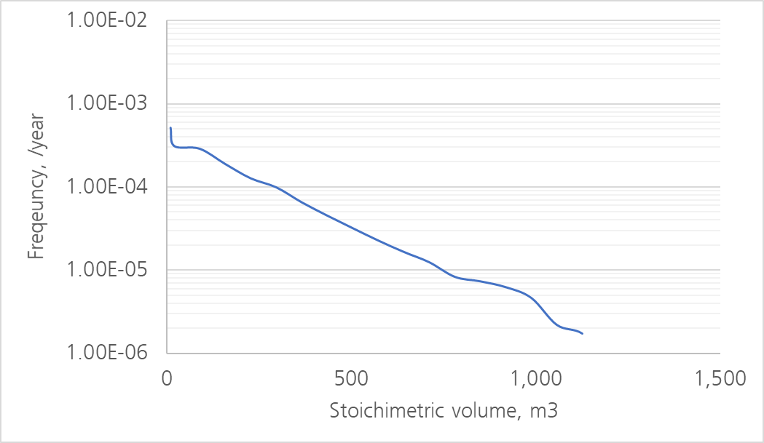

Figure . Cumulative ignition frequency as a function of stoichiometric cloud size due to internal ignition in the CCR

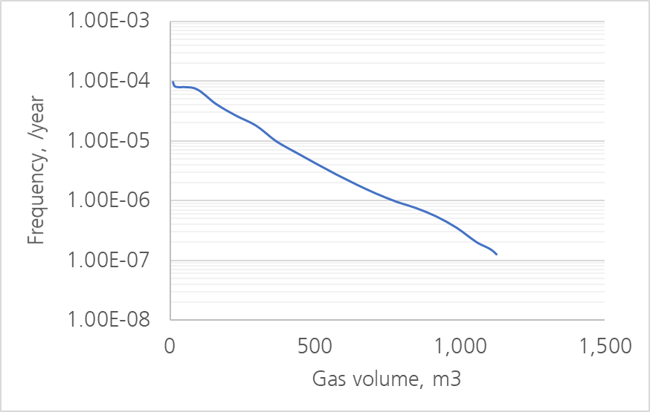

Figure . Cumulative ignition frequency as a function of stoichiometric cloud size due to internal ignition in the ER

# Explosion simulations

An explosion may take place if a flammable gas cloud in a congested area ignites; resulting in pressure both inside and in the vicinity of the ignited gas cloud. Explosion simulations are performed to calculate this load. The flame propagation depends upon geometrical properties (such as confine­ment and congestion), the gas composition, the concentration distri­bution of the ignited gas, the size of the ignited gas cloud, the location of the ignition point within the cloud and the location of the gas cloud within the rooms.

## Explosion load targets

Explosion loads were monitored on both 4 m × 4 m panels.

The targets receive an explosion load contribution from all areas within the rooms, these targets are listed in Table 7.1 and Table 7.2. Figure 7.1 and Figure 7.2 show the position of the explosion load targets.

Table . - Explosion load targets within the rooms

| Area | Target | Type of load |
| --- | --- | --- |
| CCR | Ceiling, Walls – AFT, FWD, STBD, PORT, Mezzanine | Local load: 4x4m2 panels |
| ER | Ceiling, floor, Walls – STBD, PORT | Local load: 4x4 m2 panels |

Table . - Targets for explosion events within the room spaces.

| Area | Tag no. | Type of load |
| --- | --- | --- |
| CCR | CCR spaces | Level: 36.25m  Level: 40.25m |
| ER | ER spaces | Level: 16.25m  Level: 19.25m |

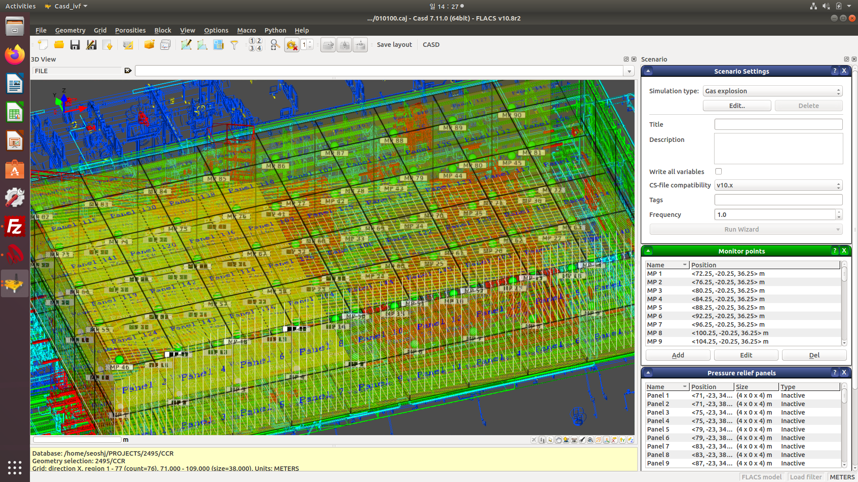

Figure . Defined pressure monitoring panels and monitoring points in CCR marked in yellow

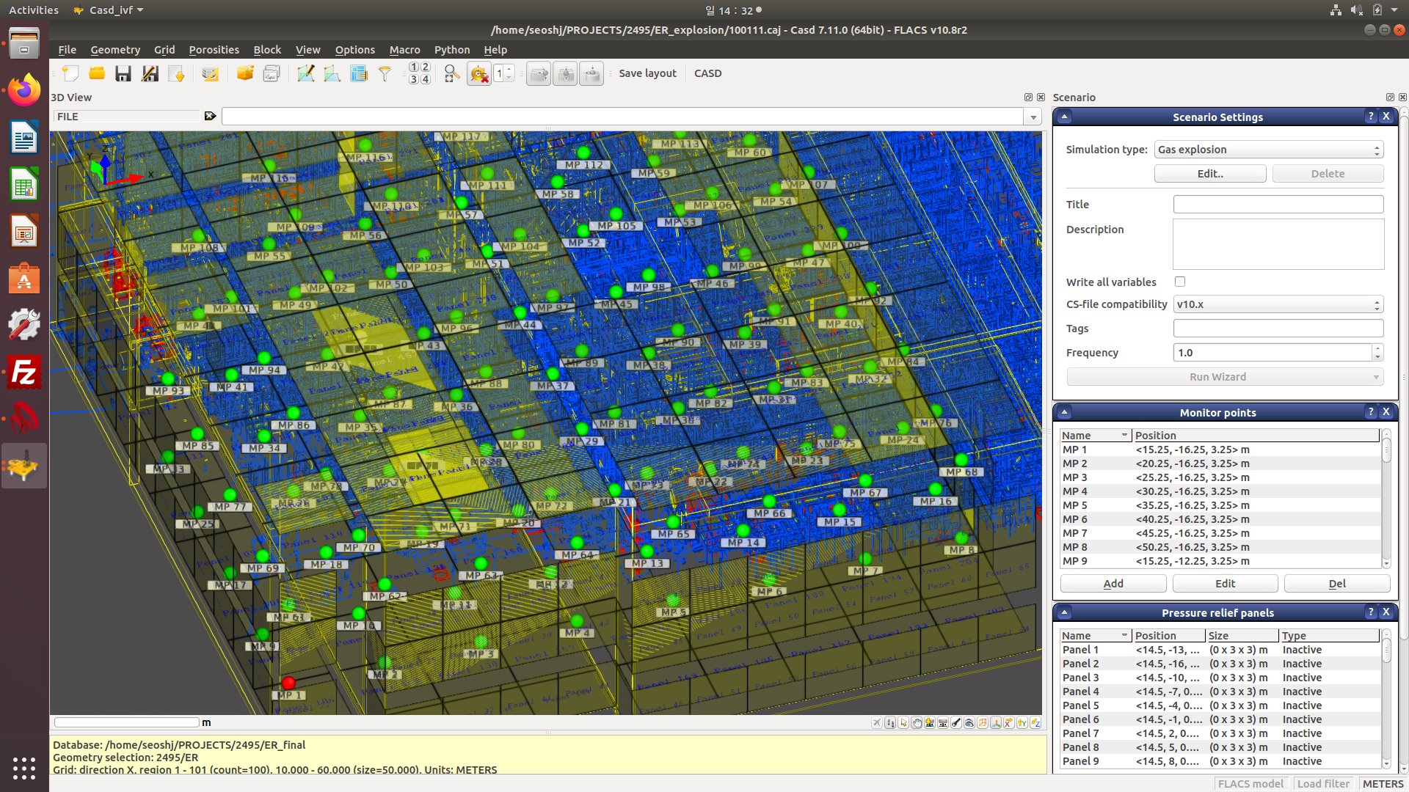

Figure . Defined pressure monitoring panels and monitoring points ER marked in yellow

## Simulated scenarios

CFD modelling by FLACS is used to predict the explosion behaviour in a flammable cloud. Combined with probabilistic assessments, the probability distribution of explosion loads at a given target can be obtained. In order to establish a sufficient statistical input to the study, a number of scenarios need to be simulated with various cloud sizes, cloud shapes, cloud locations and ignition locations.

Table 7.3 shows the number of simulated scenarios for the process area. Here, the first column denotes the gas filling as a percentage of the area volume. The gas cloud size varies from ≅ 330 m3 to 3,300 m3 for CCR and 1,800m3 to 18,000 m3 for ER in order to capture the explosion load from a wide range of gas cloud volumes. The smaller volumes are included in order to obtain accurate results for small clouds that usually have a relatively high frequency of igniting compared to larger clouds. The frequency is higher due to the fact that smaller release rates have a higher leak frequency than larger ones.

The gas clouds are spread throughout the process area - different modules as visualized in Figure 7.3. Also, each gas cloud has been ignited at three different locations, cf. Figure 7.4. Two ignition points at the edge of the cloud and one in the centre. Edge ignition typically produces higher explosion loads than central ignition, since the flame front have a longer distance to interact with congested areas.

Table . - Number of explosion simulations performed for filling percent per room

| Filling ratio in percent | # explosion simulations, CCR | # explosion simulations, ER |
| --- | --- | --- |
| 5% | 10 | 10 |
| 10% | 7 | 6 |
| 20% | 3 | 5 |
| 30% | 2 | 4 |
| 50% | 1 | 1 |
| **Total** | **23** | **26** |

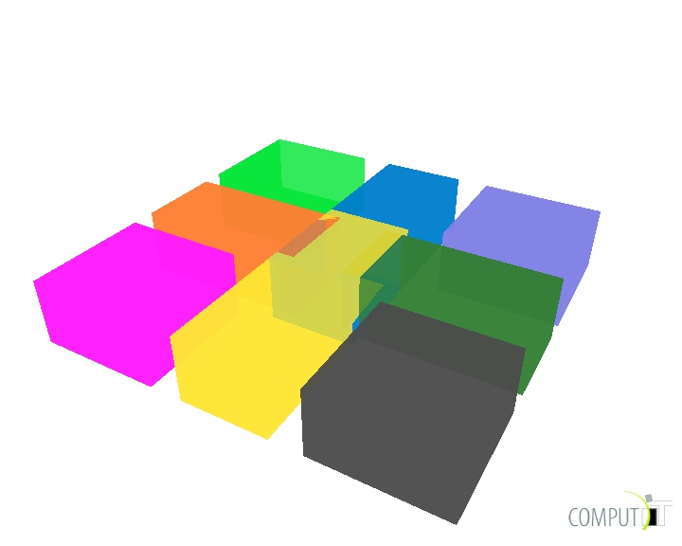

Figure . An example of the distribution of a given volume class of ignited clouds within a target area

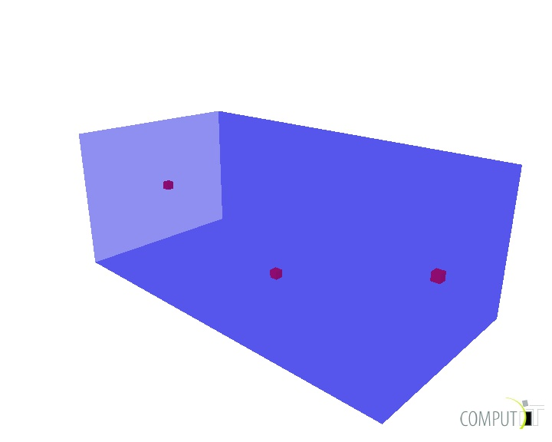

Figure . Typical distribution of the three ignition points within a given cloud

## Numerical aspects

The grid used for the explosion simulations are prepared according to FLACS best-practise guidelines, and have a 0.5 m resolution inside rooms. The grid is then stretched to 1 m in a room outside, to domain boundaries. More than 57,000 computational cells for CCR and ER are used for each simulation.

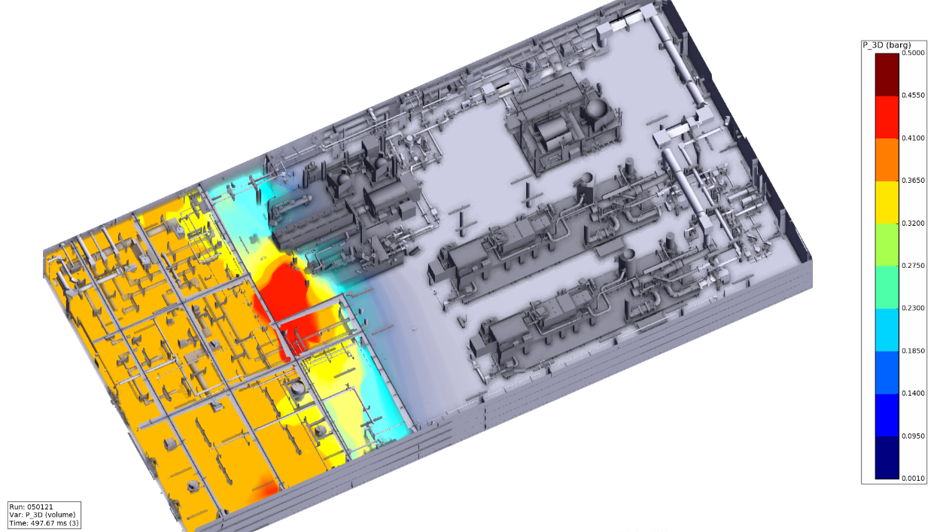

Figure . - Explosion overpressure built up by the ignition of 5% filling gas cloud in CCR

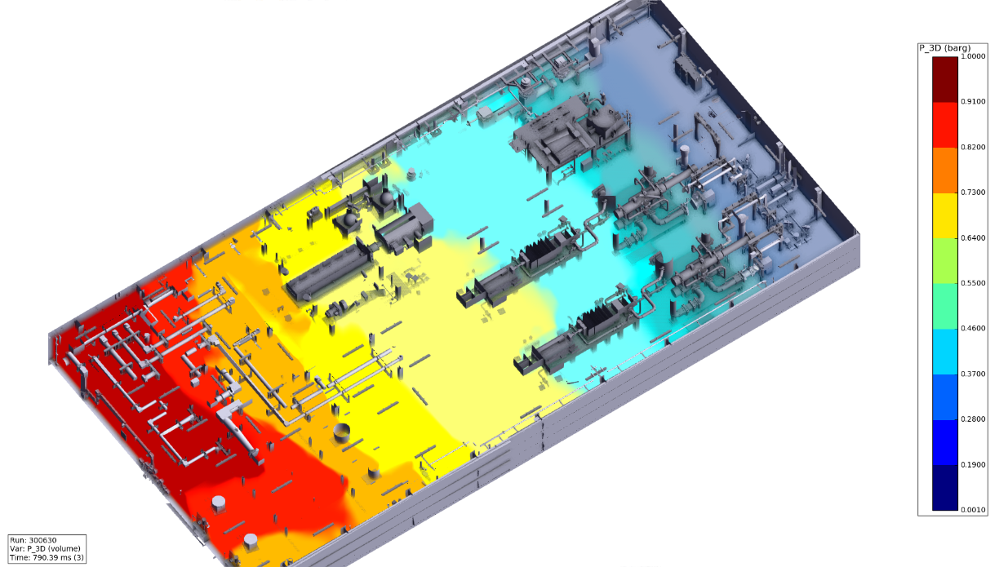

Figure . - Explosion overpressure built up by the ignition of 30% filling gas cloud in CCR

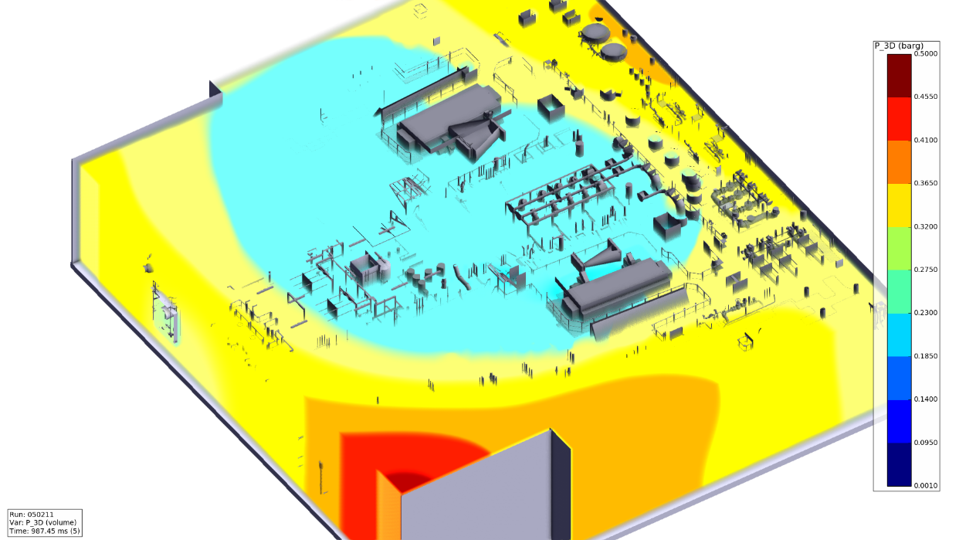

Figure . Explosion overpressure built up by the ignition of 5% filling gas cloud in ER

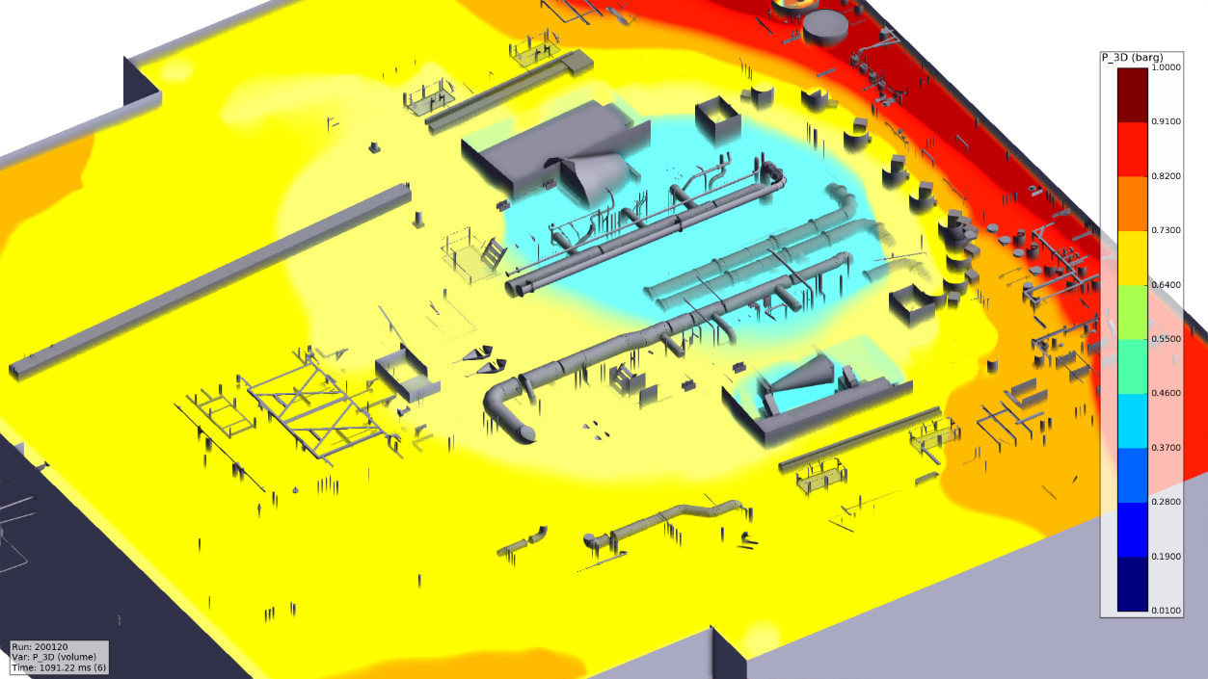

Figure . Explosion overpressure built up by the ignition of 20% filling gas cloud in ER

## Overpressure vs ignited cloud size

The results from the explosion simulations are displayed for selected targets below. The selected targets are:

* CCR – Ceiling, Walls – AFT, FWD, STBD, PORT, Mezzanine,
* ER - Ceiling, floor, Walls – STBD, PORT.

Figure 7.9 to Figure 7.15 shows the explosion pressures on selected targets, due to events on the room area. More than 3 barg is observed by explosions event with 50% filling gas cloud.

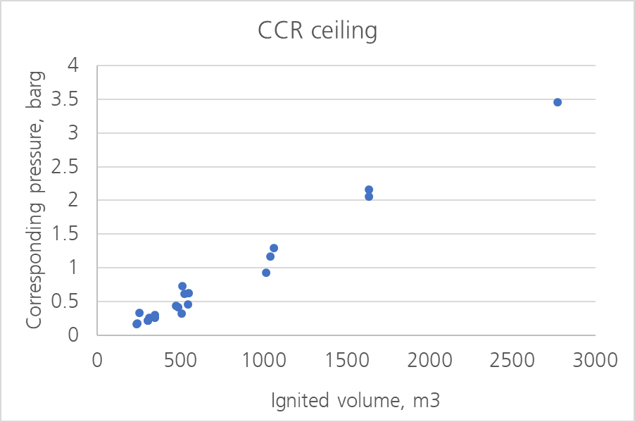

Figure . Local explosion loads on the CCR ceiling

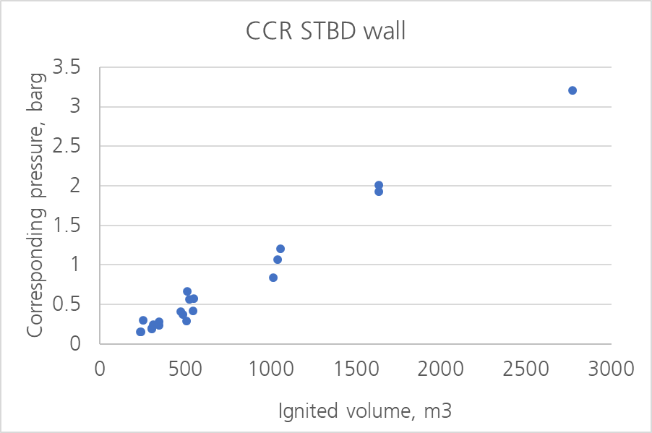

Figure . Local explosion loads on the CCR STBD wall

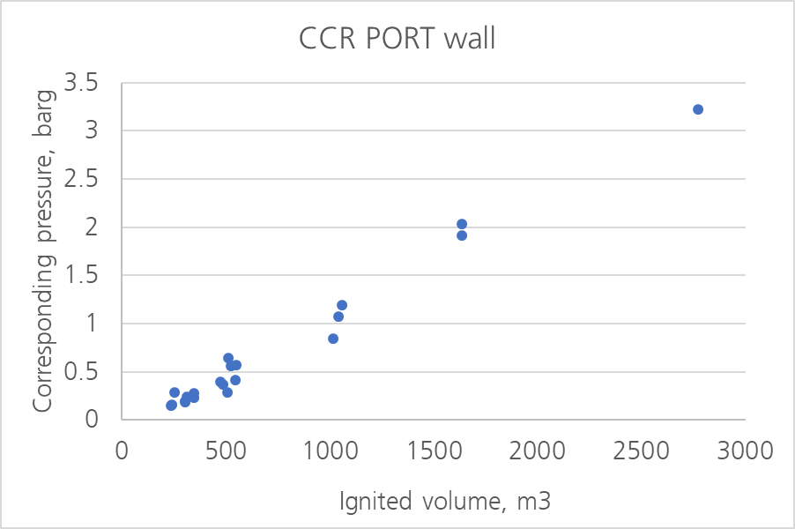

Figure . Local explosion loads on the CCR PORT wall

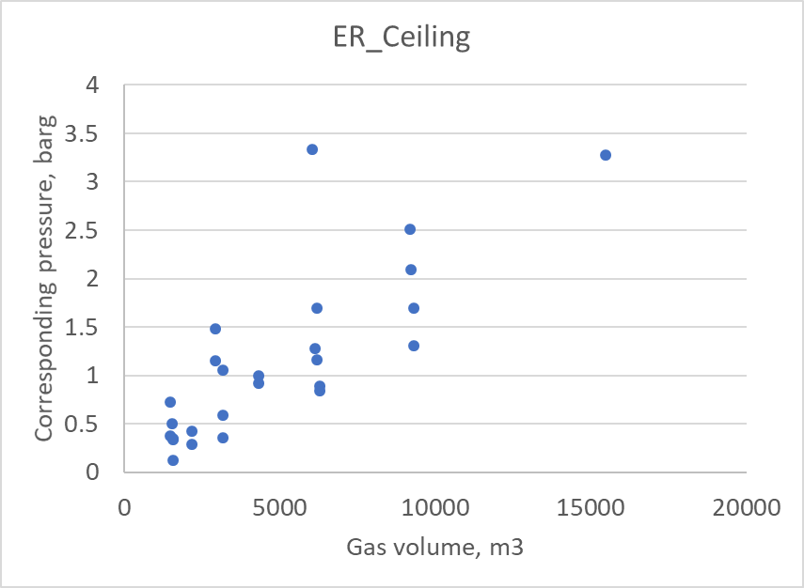

Figure . Local explosion loads on the ER ceiling

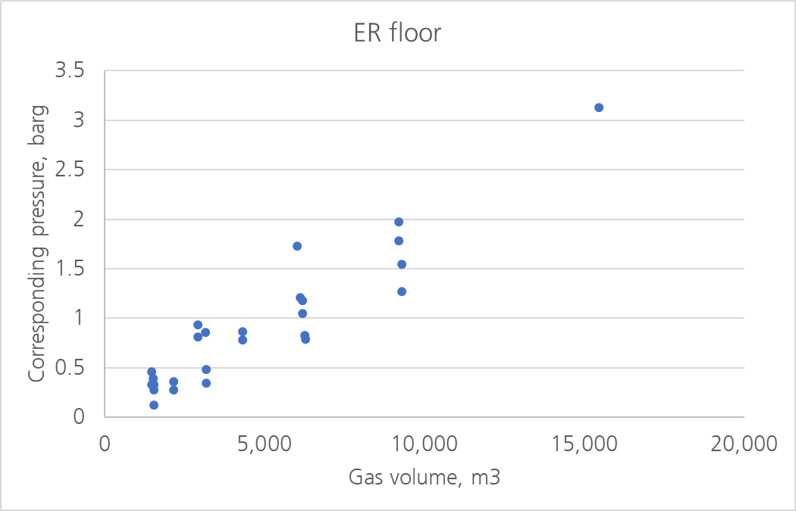

Figure . Local explosion loads on the ER floor

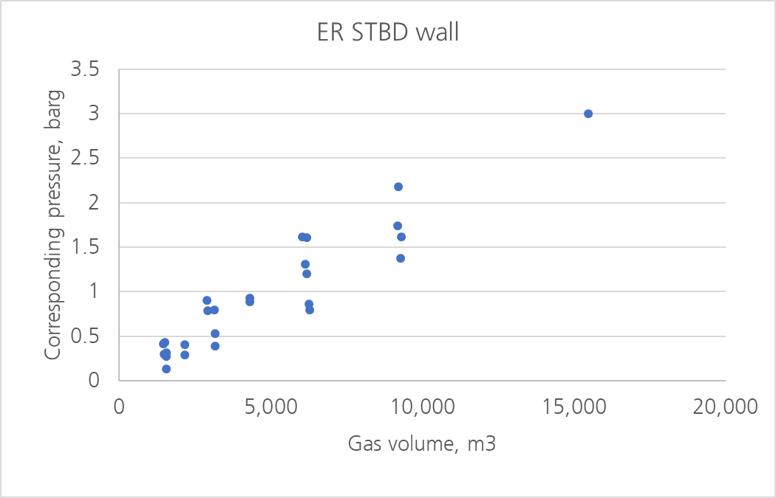

Figure . Local explosion loads on the ER STBD wall

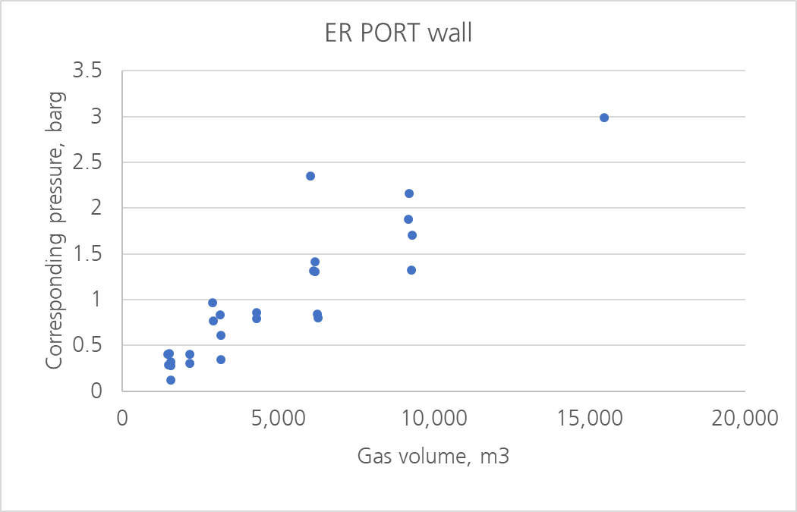

Figure . Local explosion loads on the ER PORT wall

## Explosion load durations

In order to capture the full effect of an explosion on a given target it is important to analyse the maximum load as well as the transient development of the load over time. A typical pressure load over time curve from an ignited gas cloud can be seen in Figure 7.16. It shows how the pressure varies over time for one of the panels where the pressure is monitored. It can also be seen that the maximum pressure occurs in the first pressure peak, which is typical. The maximum pressure load is usually reported toget­her with a frequency for further processing into cumulative pressure exceedance curves.

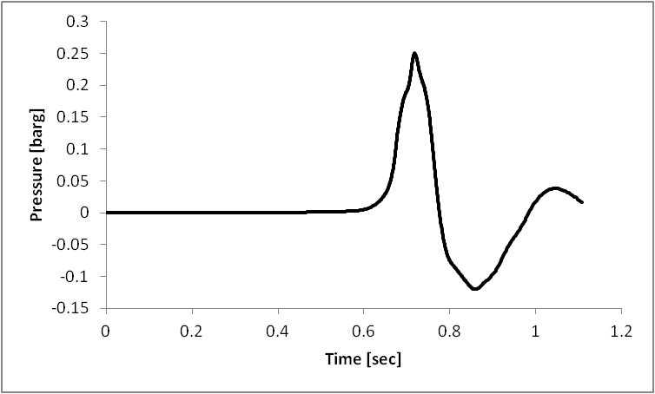

Figure . An example of pressure as a function of time for one local panel

It is therefore necessary to consider duration of the pressure which is usually done for the first and the second peaks, normally corresponding to the maximum and minimum pressure.

The dura­tion can be calculated with following equation:

$$I=\int_{t0}^{t1}{p(t)dt}$$

where I is the impulse, t is the time and p(t) is the pressure as a function of time. The press­ure as a function of time for the first and second peaks will, in most cases, have a shape which is close to a triangle and therefore this formula can be approximated with the following equation:

$$∆t=\frac{2I}{p_{m}}$$

where pm is the maximum or minimum local or global pressure. Figure 7.17 shows the app­roxi­mated pressure time relation for the first period. The duration for pmax and pmin can be calculated according to following equations:

$$d=\left\{\begin{matrix}t_{1}-t_{0} p>0 \\ t_{2}-t_{1} p<0\end{matrix}\right.$$

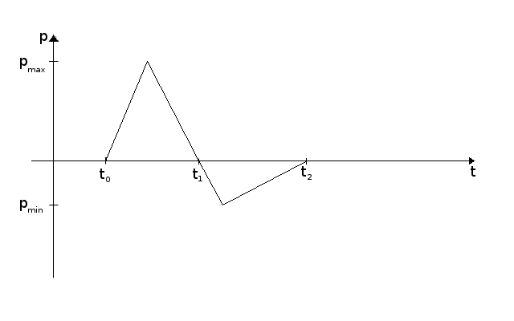

Figure . The approximated shape of the pressure time curve

The duration was then be calculated for all simulated scenarios and plotted in a pressure duration plot in order to come up with a relation between press­ure and duration.

In the subsequent sections raw duration-data from the simulations is presented for different targets.

Durations at design accidental load for selected targets are given in Table 7.4. It is observed that overall explosion events generate relatively long duration due to insufficient pressure release by the explosion occurs in enclosed spaces.

Table . - Durations at design accidental load for different barriers

| Target | Local design accidental load, barg | Duration range of global load, ms |
| --- | --- | --- |
| CCR_AFT_wall | 0.23 | 1,100 ~ 3,298 |
| CCR_FWD_wall | 0.23 | 1,989 ~ 3,302 |
| CCR_PORT_wall | 0.24 | 1,974 ~ 3,308 |
| CCR_STBD_wall | 0.23 | 1,967 ~ 3,313 |
| CCR_ceiling | 0.24 | 1,130 ~ 3,326 |
| CCR_mezzanine | 0.13 | < 60 |

# Probabilistic explosion loads

The final stage in this probabilistic explosion analysis is to combine the ignited equivalent stoichiometric gas cloud volumes given in Section 6.3 with explosion loads for given cloud sizes given in Section 7.4. This results in pressure-frequency curves, which are presented in the proceeding sub-sections.

## Pressure-frequency curves for CCR

The pressure-frequency curves for local loads on the targets in the CCR are given in Table 8.1, Table 8.2 and from Figure 8.1 to Figure 8.4.

Table . Design accidental explosion loads exceeding 1E-04/year for the CCR

| Target | Accidental local load exceeding 1.0E-4/year frequency, barg | Accidental global load exceeding 1.0E-4/year frequency, barg |
| --- | --- | --- |
| CCR_AFT_wall | 0.23 | 0.21 |
| CCR_FWD_wall | 0.23 | 0.22 |
| CCR_PORT_wall | 0.24 | 0.19 |
| CCR_STBD_wall | 0.23 | 0.19 |
| CCR_ceiling | 0.24 | 0.22 |
| CCR_mezzanine | 0.13 | 0.04 |

Table . Design accidental explosion loads exceeding 1E-04/year for the CCR

|  |  |  |
| --- | --- | --- |
| CCR_Level 36.25 | 0.24 | 0.21 |
| CCR_Level 40.25 | 0.23 | 0.21 |

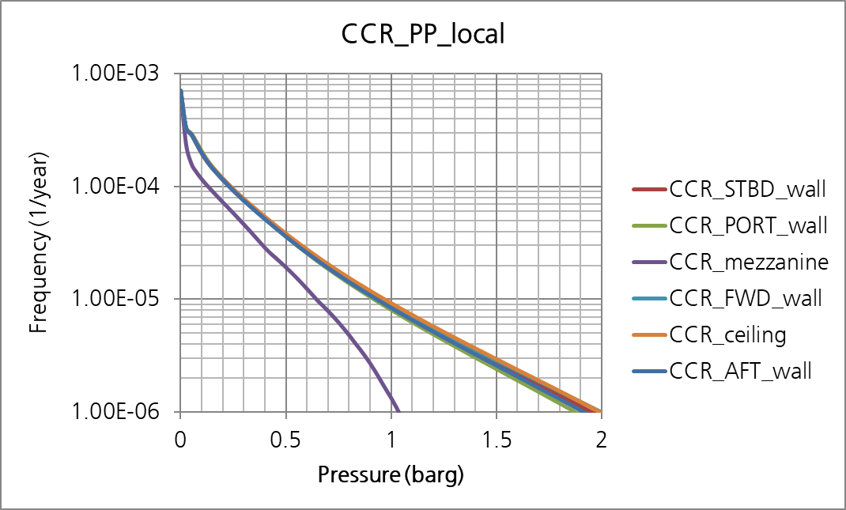

Figure . Pressure-frequency curves for local loads on the CCR - walls/ ceiling

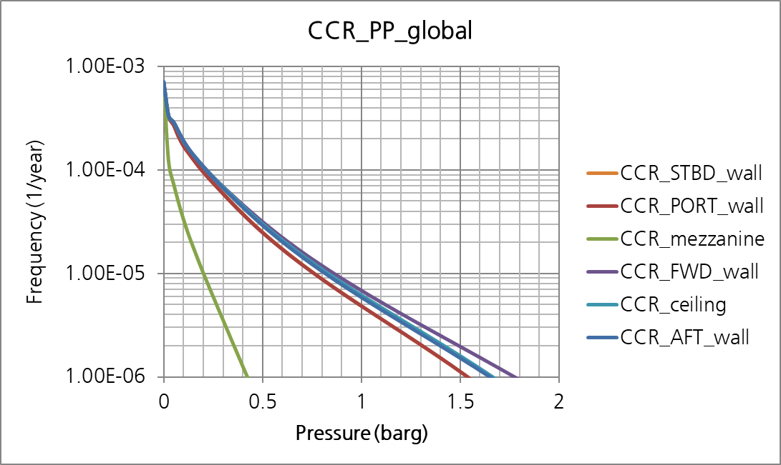

Figure . Pressure-frequency curves for global loads on the CCR - walls/ ceiling

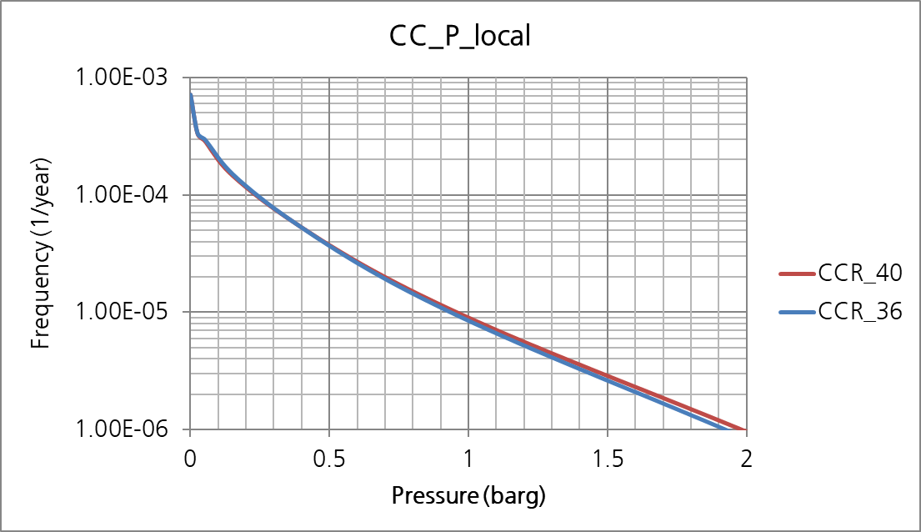

Figure . Pressure-frequency curves for local loads inside the CCR

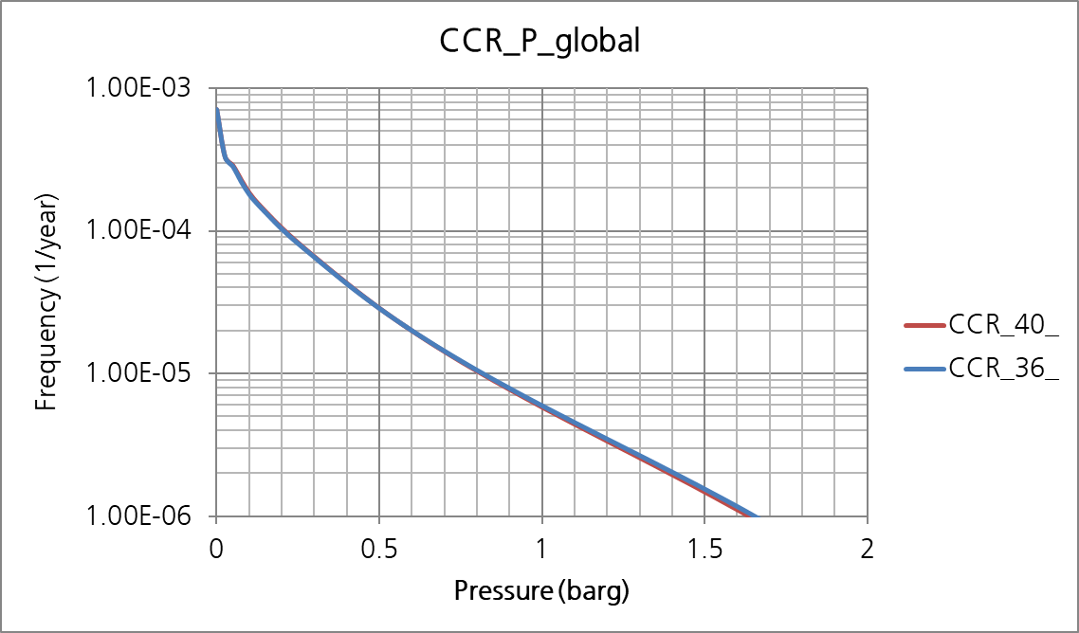

Figure . Pressure-frequency curves for global loads inside the CCR

## Pressure-frequency curves for ER

The pressure-frequency curves for local loads on the targets in the CCR are given in Table 8.3, Table 8.4, and from Figure 8.5 to Figure 8.8.

Table . Design accidental explosion loads exceeding 1E-04/year for the ER

|  |  |  |  |  |
| --- | --- | --- | --- | --- |
| 1 | ER_PORT_wall | < 0.01 | < 0.01 | n/a |
| 2 | ER_STBD_wall | < 0.01 | < 0.01 | n/a |
|  | ER_Ceiling | < 0.01 | < 0.01 | n/a |
|  | ER_floor | < 0.01 | < 0.01 | n/a |

Table . Design accidental explosion loads exceeding 1E-04/year for the ER

|  |  |  |  |
| --- | --- | --- | --- |
| 1 | ER_Level 16.25 | < 0.01 | < 0.01 |
| 2 | ER_Level 19.25 | 0.01 | < 0.01 |

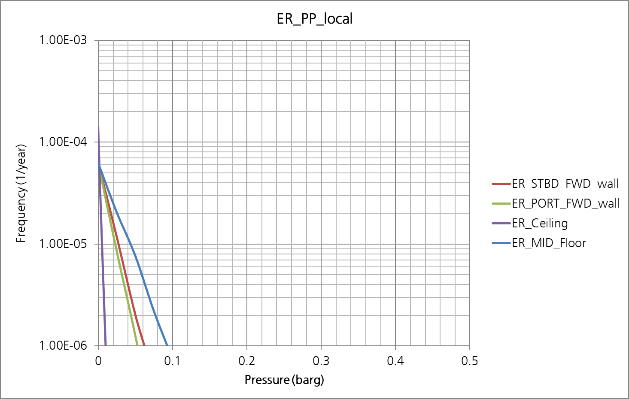

Figure . Pressure-frequency curves for local loads on the targets in the ER

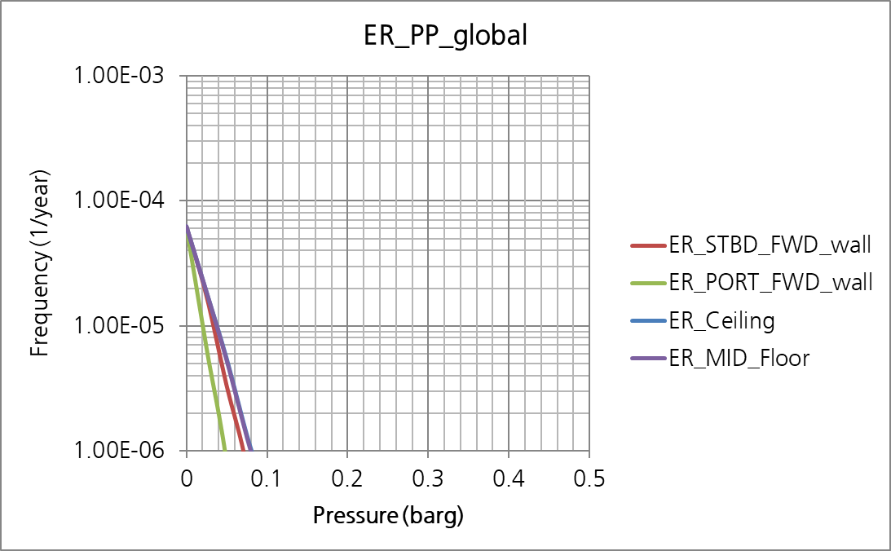

Figure . Pressure-frequency curves for global loads on the targets in the ER

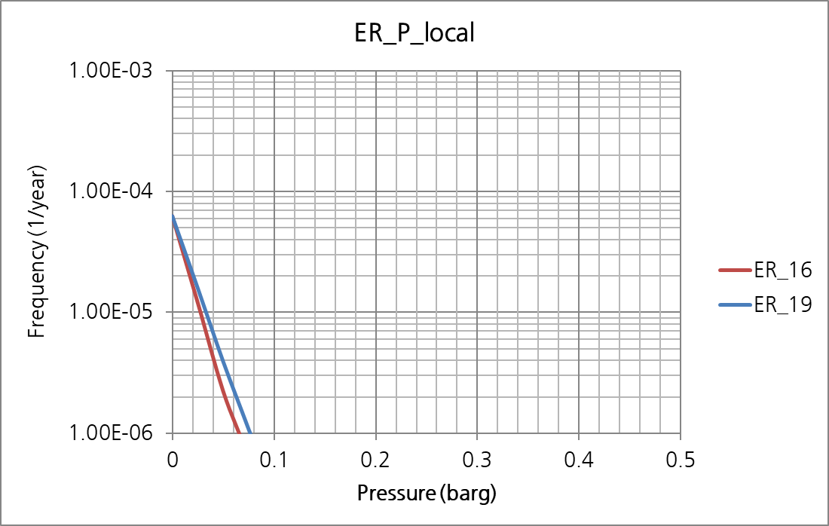

Figure . Pressure-frequency curves for local loads inside the ER

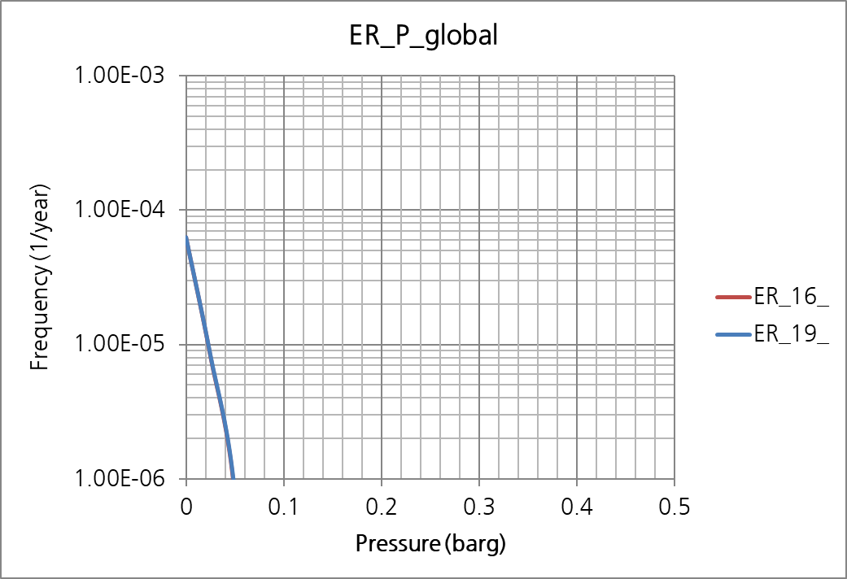

Figure . Pressure-frequency curves for global loads inside the ER

# Fire Risk Analysis using PHAST in CCR

Fire risk analysis is performed in for probable leakages in CCR. Leakage higher 0.1 kg/sec is analysed using PHAST which is a popular consequence tool. The tool doesn’t consider effect of congestion or confinement around the leak but it can give a basic data on probable consequence from various leak scenarios with time varying discharge profiles.

Consequences are processed with the frequency evaluation data to derive dimensioning scenarios that are expected to happen once in 10,000 years of operation.

## Discharge Calculation

There are five process segments in CCR as shown in Table 9.1. Segment 1 and 2 have very low pressure (Table 9.2) and leak at these segments will have too low momentum. These two segments decided not to be considered for fire analysis.

Table 9.1 Description of segment and area

| Segment No. | Description | Area |
| --- | --- | --- |
| Segment 1 | A-PRS | A01 |
| Segment 2 | A-PRS to FG compressor | A01 |
| Segment 3 | FG compressor | A01 |
| Segment 8 | BOG boosting compressor to A-PRS | A01 |
| Segment 9 | BOG return from A-PRS | A01 |

Table 9.2 Operating conditions, volume, and total mass of the segment

| Seg No. | Phase | Temp. (°C) | Pressure (bara) | Mass flowrate (kg/s) | Density (kg/m3) | Volume (m3) | Total mass (kg) |
| --- | --- | --- | --- | --- | --- | --- | --- |
| 1 | Gas | -133.9 | 1.05 | 1.33 | 1.65 | 6.00 | 9.9 |
| 2 | Gas | 24.5 | 1.02 | 1.33 | 1.65 | 6.00 | 9.9 |
| 3 | Gas | 43.0 | Outlet:13 | 1.33 | 5.55 | 6.36 | 35.3 |
| 8 | Gas | 43.0 | Outlet:151 | 0.73 | 110.78 | 6.05 | 362.1 |
| 9 | Liquid + Gas | -147.6 | 4.01 | 0.46 | Liq.:394.40Gas: 7.98 | Liq.: 0.37 Gas: 1.90 | 161.1 |

Initial leak from each segment of four hole sizes are tabulated in Table 9.3.

Table 9.3 Initial gas leak rate [kg/s] – Leak smaller than 0.1 kg/s will be disregarded

| Seg No. | Pressure (bara) | Small | Medium | Major | Large |
| --- | --- | --- | --- | --- | --- |
| 3 | Outlet:13 | 0.05 | 0.16 | 0.58 | 0.90 |
| 8 | Outlet:151 | 0.62 | 2.07 | 7.09 | 9.60 |
| 9 | 4.01 | 0.24 | 0.80 | 2.87 | 4.38 |

The initial rate from each segment will be maintained with the continuous flow from other segment until the leak is confirmed and the segment is isolated. When the segment is provided with a blowdown valve, the segment will be depressurized more quickly.

It is assumed that gas detection will activate the safety systems at the designated times after the release as listed in Table 9.4.

Table 9.4 Activation timing of Isolation & Blowdown

| Safety system | Small | Medium | Major | Large |
| --- | --- | --- | --- | --- |
| Confirmed gas detection & Isolation start after release | 60 | 30 | 10 | 5 |
| Blowdown start after having initiated isolation | 180 | 180 | 180 | 180 |
| Blowdown start after release | 240 | 210 | 190 | 185 |

Figure 9.1 shows that a release at Segment 8 (S8) will be maintained at the initial release rate of 2.07 kg/sec and will decrease as the segment pressure drops after the segment is isolated at 30 seconds after the release and further decreased when the blowdown system is activated at 210 seconds.

Time varying profiles of all leak scenarios are included in Appendix A.

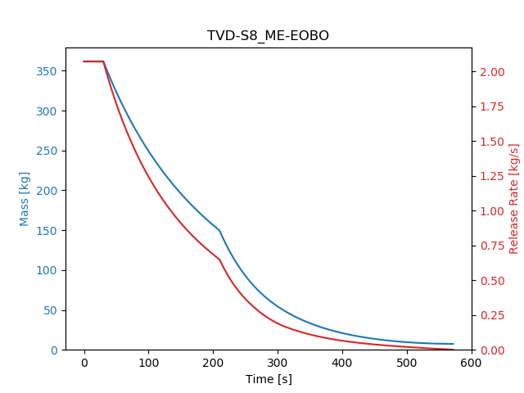

Figure 9.1 Time-varying leak profile – S8 Medium size hole

## Consequence Calculation

PHAST evaluates probable consequences from the leak. Probable consequences of leaks from the three segments in CCR are:

* Flammable dispersion
* Jet fire
* Explosion

Segment 9 has liquid inventory and discharge from it will contain liquid in the fraction of 91%. Pool fire, however, is not calculated to be probable. Explosion results from PHAST are not regarded relevant for a mechanical ventilated congested area like CCR.

Results of flash fire, flammable dispersion, and jet fire can be shown respectively using the dispersion extent of 50% LFL cloud, dispersion extent of 100% LFL and the jet fire shape. Figure 9.2 shows the areas within 100% and 50% LFL of gas cloud and the shape of jet fire of a leak through a major size hole of Segment 9. The location of the leak is assumed to be between the compressor and A-PRS. It is shown that the jet fire will reach the aft wall of CCR.

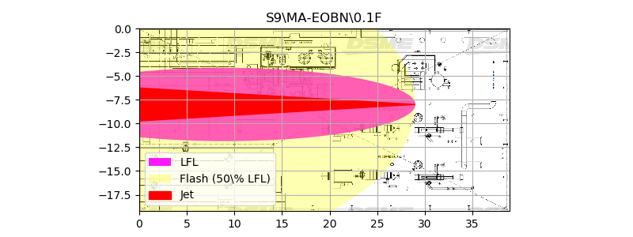

Figure 9.2 Consequence map

Consequence maps of all leak scenarios are included in Appendix B.

## Dimensioning Load Evaluation

The frequency of each consequence is combined to derive dimensioning load from jet fire which is to be considered for design.

Not only the leak frequency but also an ignition model are necessary to evaluate frequency of jet fire. The OLF ignition probability model is used to evaluate the immediate ignition probabilities depending on the initial release that will be used for the jet pool fires.

Table 9.5 Event i.e. immediate ignition probability model

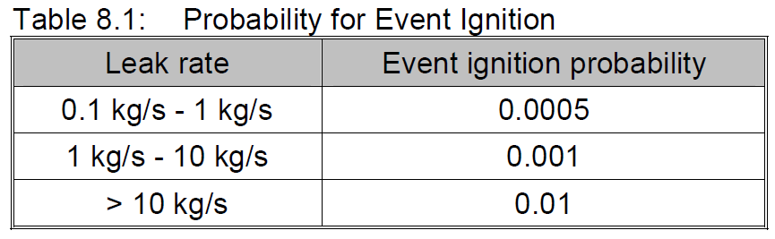

To derive dimensioning load from jet fire, the jet length at some time after the release has been used to assess how wide area would be expose to jet flame directly. Should a safety critical equipment or structure be subject to direct impingement of the jet fire at the time, it need to be adequately protected not to be impaired by that dimensioning jet fire.

It has been an offshore practice to designate an accident that may happen once in 10,000 years of operation to be withstood. The jet fire lengths expected at the instant of release, five minutes after the release, and ten minutes after the release are derived using the release rate at that time and the Lowesmith formula for jet fire length.

L = 2.8893 x Q 0.3728 [meter]

where Q is the net calorific value of the release (= mass release rate x net calorific value/kg).

At the instant of release, the large jet fire will be 38 meter long. Exceedance curve for the jet fire length at the instant of release is shown in Figure 9.3. The jet fire length corresponding to the cumulative frequency of the dimensioning criterion of 1.0E-4/year is evaluated to be 5.5m.

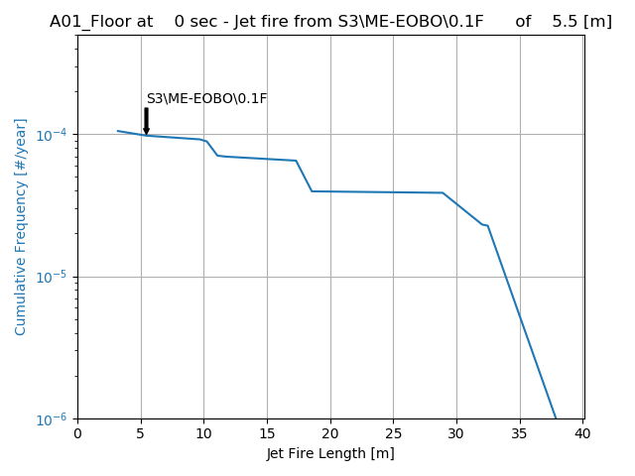

Figure 9.3 Exceedance curve of jet fire length at T = 0 min

Five minutes after the release, releases from large holes are no longer maintained to have jet fires and there will no dimensioning scenarios as shown in Figure 9.4. This means that the dimension jet fire of 5.5 meter will not last longer than 5 minutes.

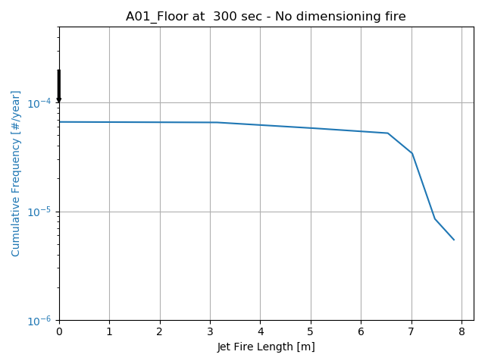

Figure 9.4 Exceedance curve of jet fire length at T = 5 min

# Conclusion

The fire and explosion risk in the CCR and ER of H2496s LNG carrier has been addressed in this study.

The LNG process is analysed for isolatable segments and leak frequencies from each segment are evaluated using LR RMC’s tool ULF.

Explosion risk analysis

The explosion risk on H2496 is modest and well within the risk acceptance criteria. Below is a summary of the main findings:

* Maximum accidental design load observed in the CCR over 1E-4 per year is 2.24 barg that CCR ceiling experiences. It should be noted that the study applied the 1E-4 per year of impairment frequency for offshore oil & gas project thus judgement on derived loads should be made considering operation life of H2495s.
* No meaningful accidental design loads observed in the ER over 1E-4 per year are observed due to limited accommodation of fuel gas process within ER that leads to very low leak frequency. It can be concluded that the dimensioning accidental loads on the ER of 2495s are acceptable.

Overall, the present study demonstrates that the design of H2495s CCR and ER are vulnerable to explosion have a sufficient robustness, and all of the acceptance criteria related to explosion loads are met.

Fire risk analysis

Fire risk analysis is performed using PHAST to evaluate consequences for flammable gas dispersion, flash fire, and jet fire. Combining the frequency and the jet fire length expected from each leak events, dimensioning fire scenario is derived. At the instant of release, the dimensioning jet fire in CCR will be 5.5 meter long. The jet fire, however, will shrink quickly as the release rate decreases in time. In five minutes the cumulative frequency of having a jet fire will be less than dimensioning.

# References

1. [] DNV, Offshore QRA – Standardised Hydrocarbon Leak Frequencies, Report no/DNV Reg No.: 2008-1768/ 1241Y35-14 Rev 1, 2009-01-16
2.